**IS-698 Homework 3 – UB01976**

### **Part 1: AWS CloudFormation**

#### **Task: Automate Infrastructure with CloudFormation**

* Write a **CloudFormation template** (YAML or JSON) to deploy the following:
  + A VPC with public and private subnets
  + An EC2 instance in the public subnet
  + An S3 bucket
  + A Lambda function triggered by S3 object creation
* Use **Parameters**, **Mappings**, **Conditions**, and **Outputs** to demonstrate good practices.
* Validate and deploy the stack using the AWS Management Console or AWS CLI.

**CloudFormation template (YAML) -**

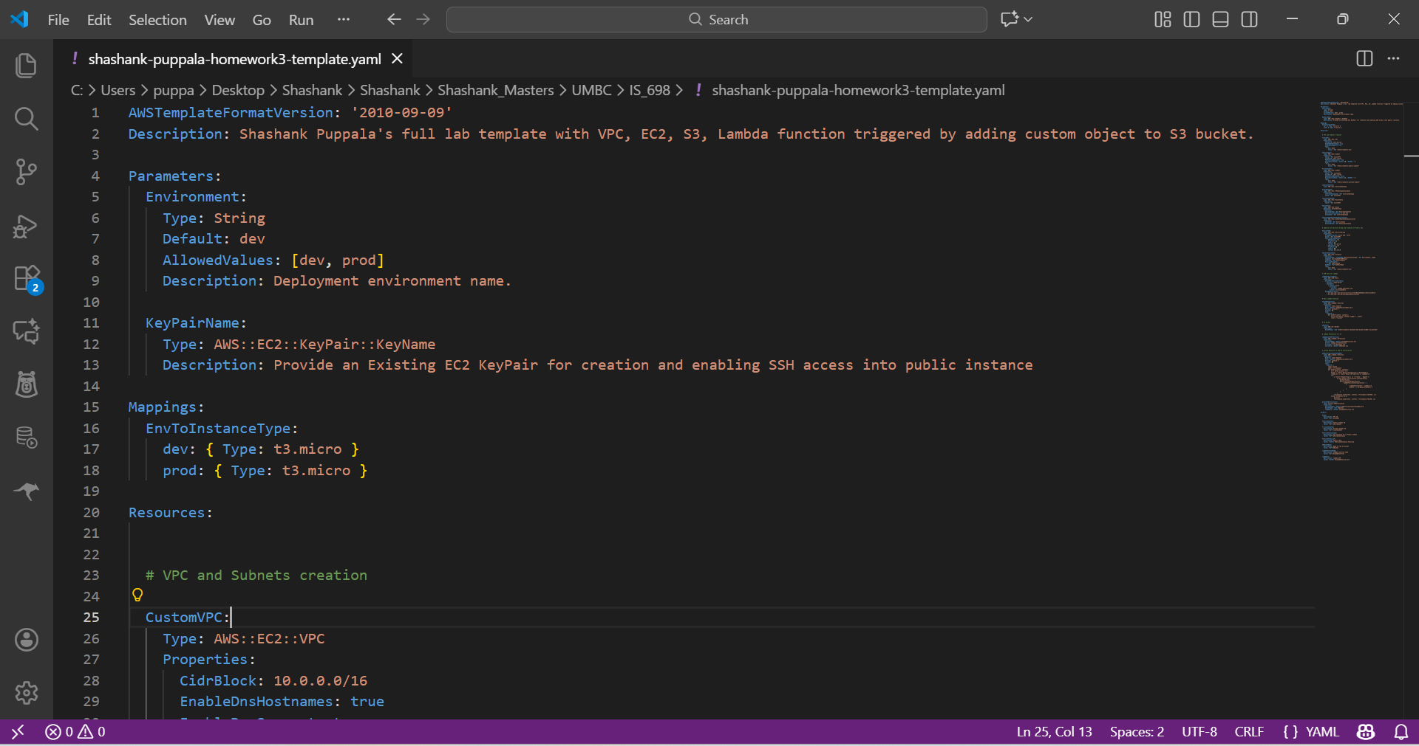

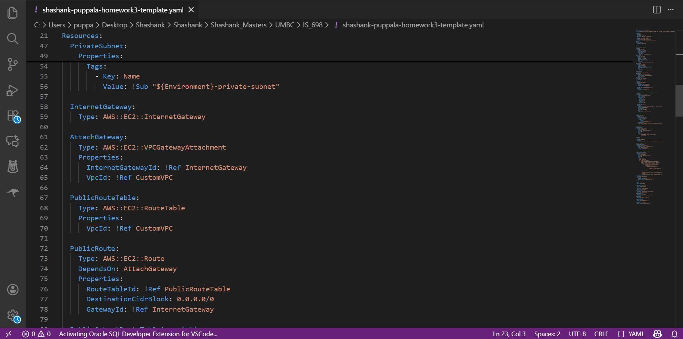

**Uploading the template and deploying the stack in cloud formation -**

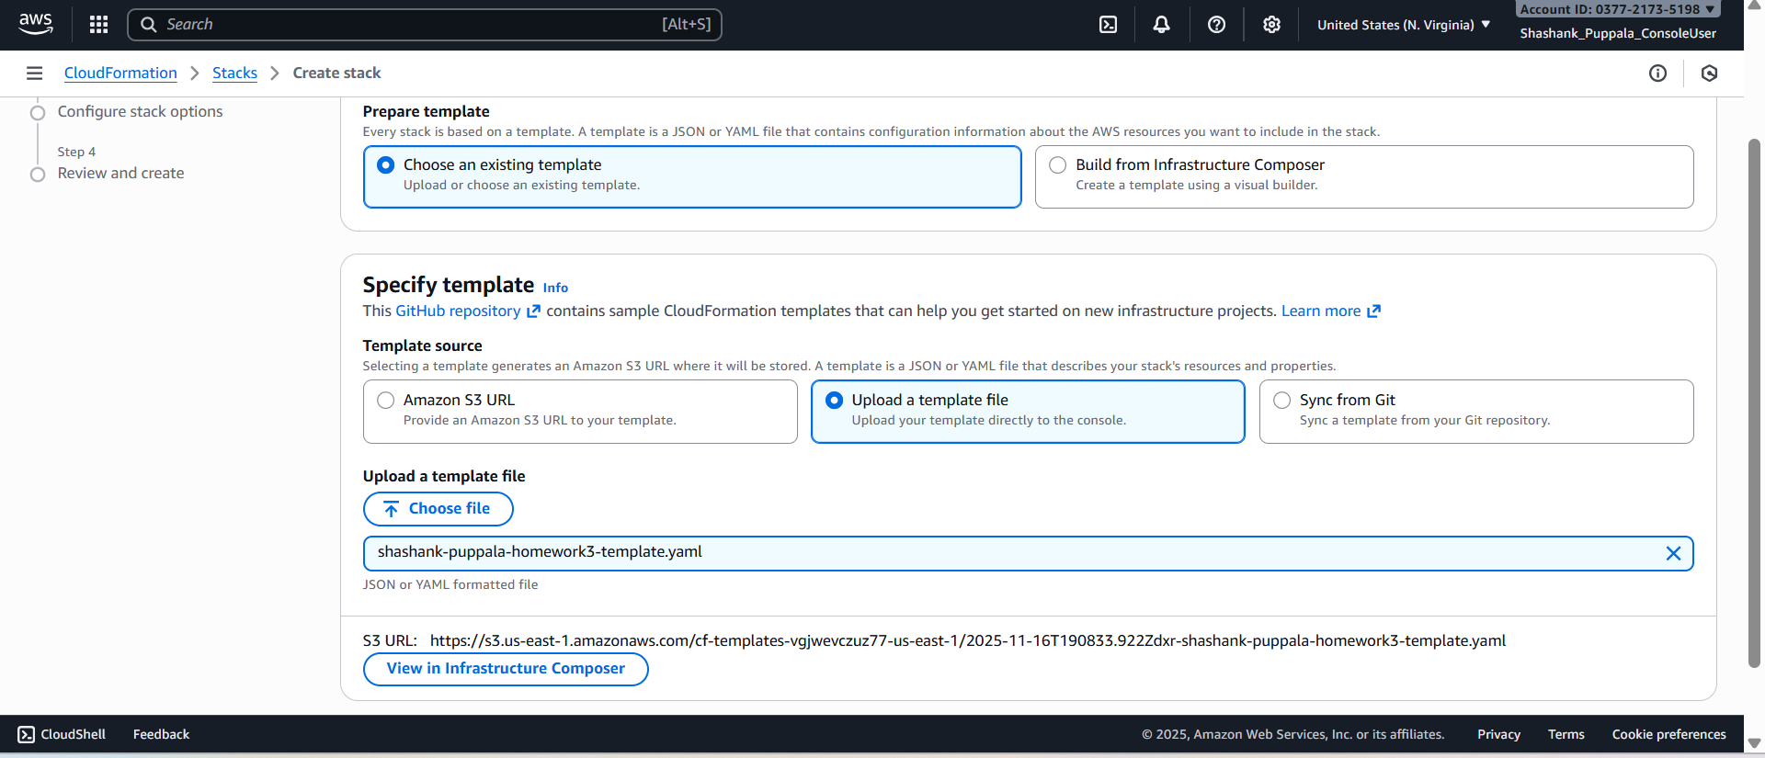

**Deployed stack for creating resources related to dev environment -**

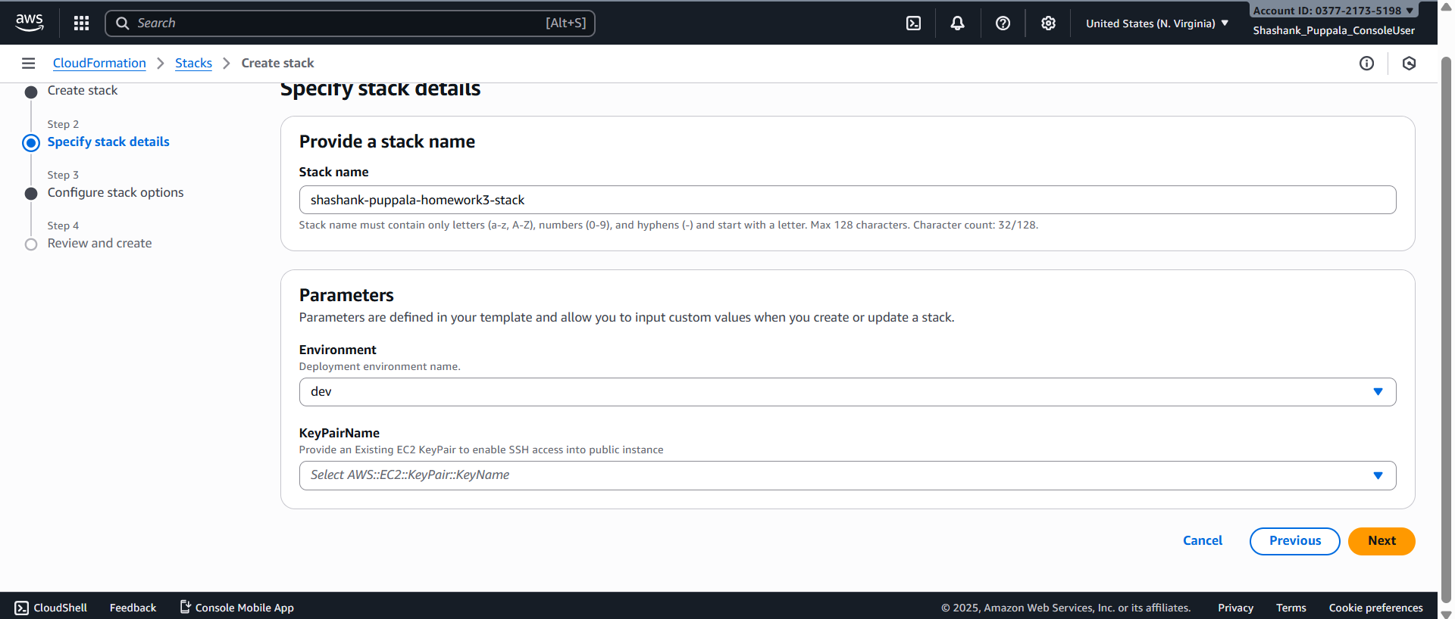

**(Note: - Please select a valid keypair value from the account for creation of the public EC2 before deploying the stack)**

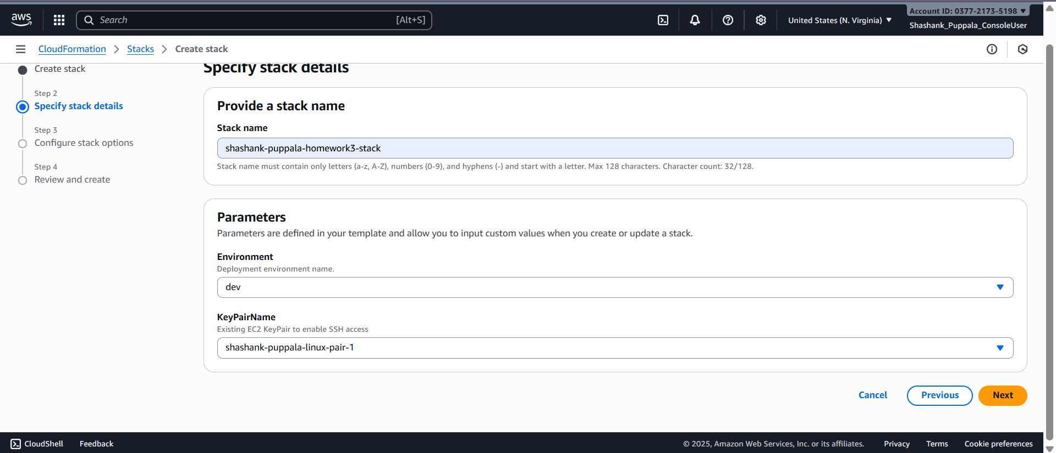

**Stack successfully deployed and Resources created -**

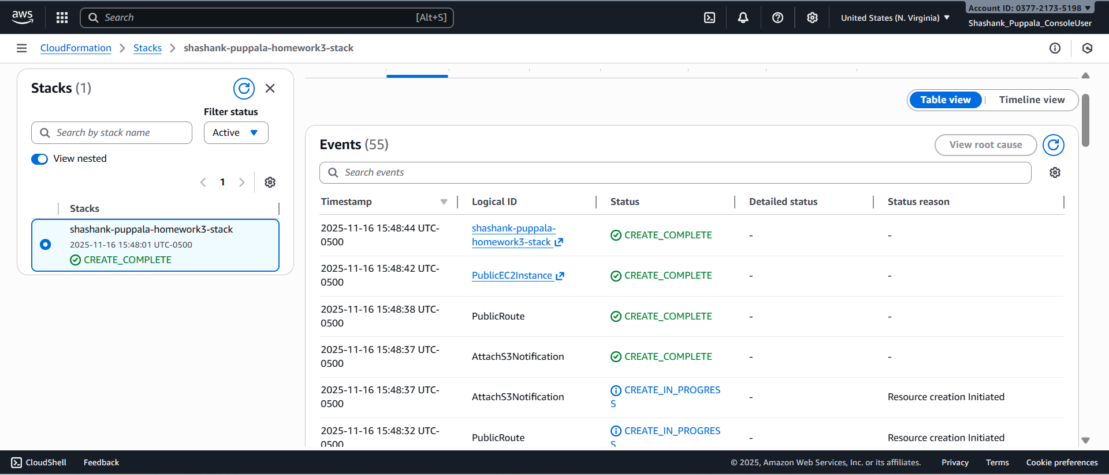

**Validation whether all the resources are created or not at AWS Console**

**VPC -**

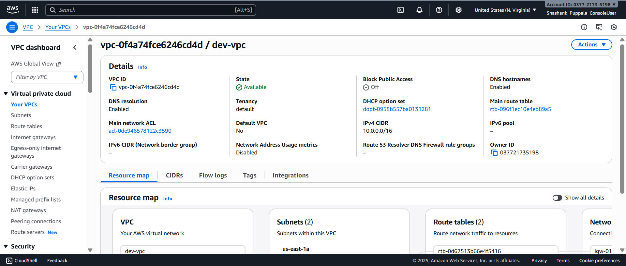

**Subnets -**

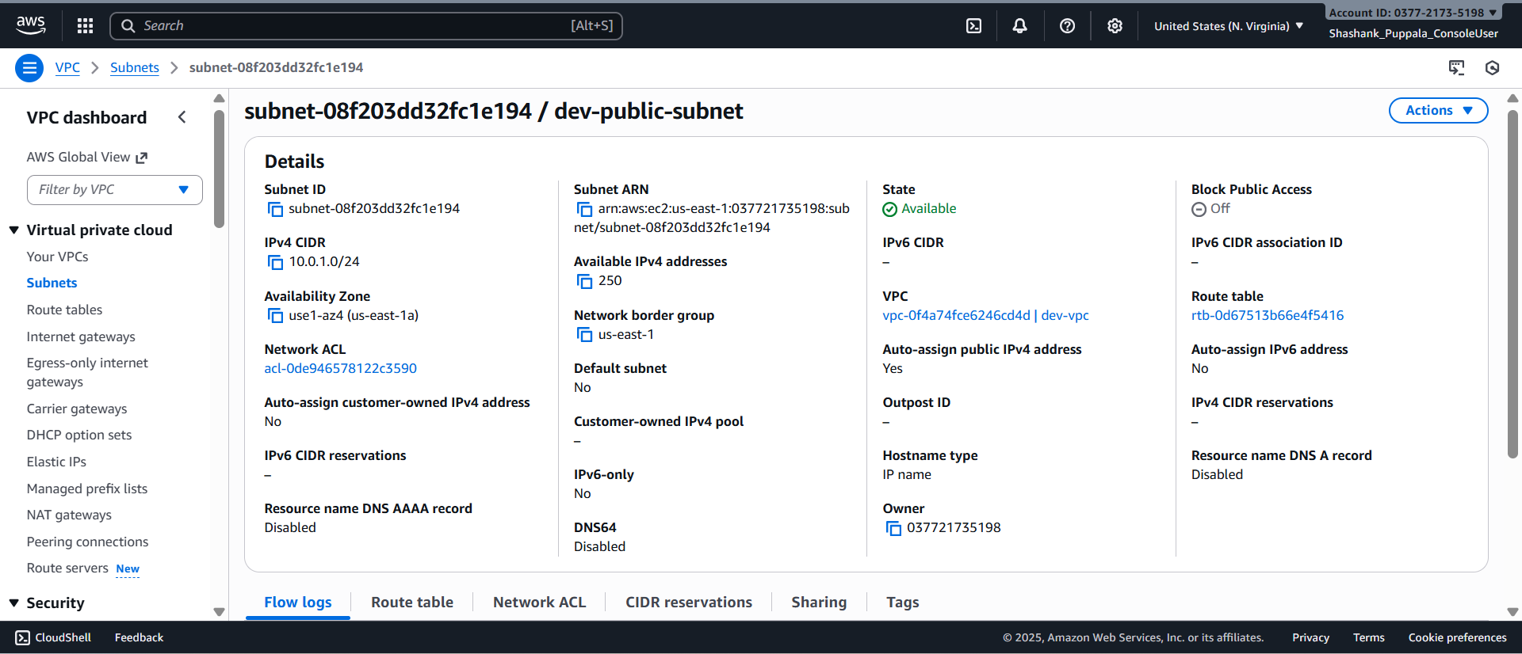

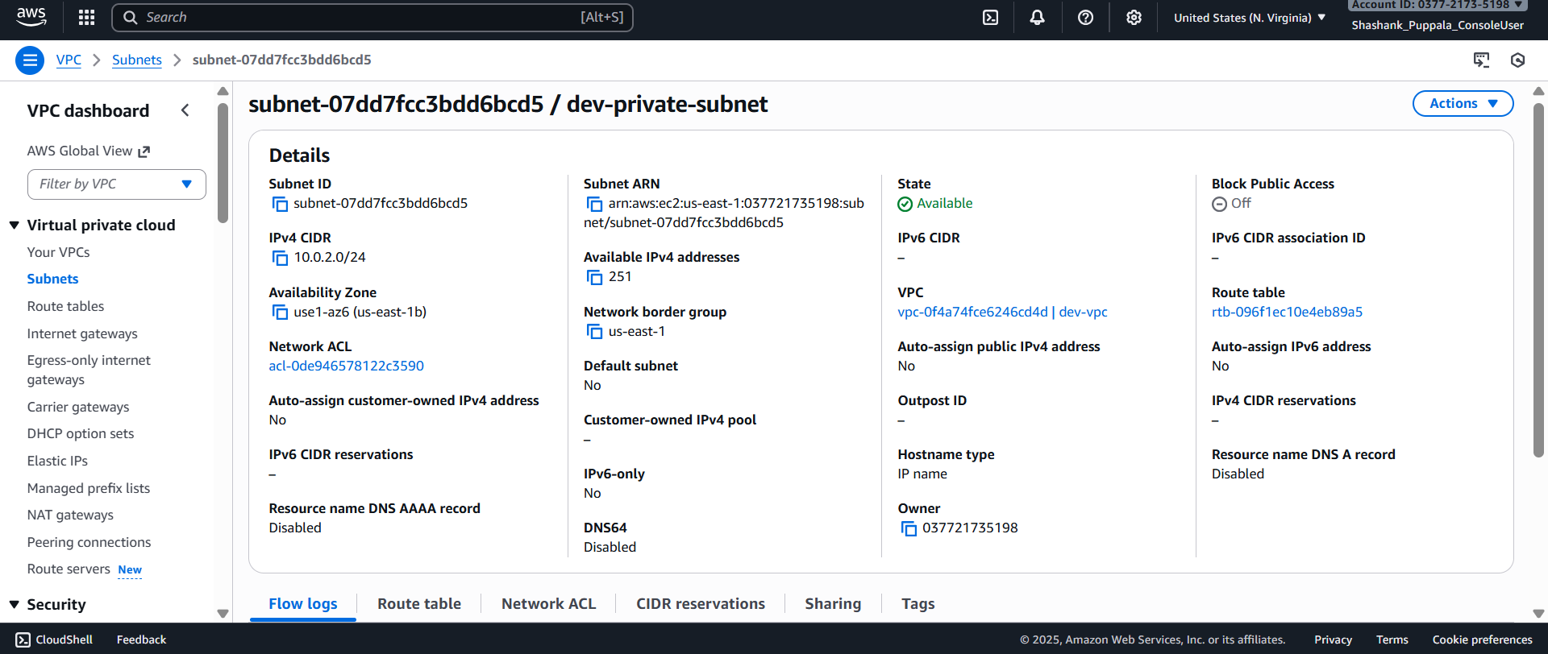

**Route table -**

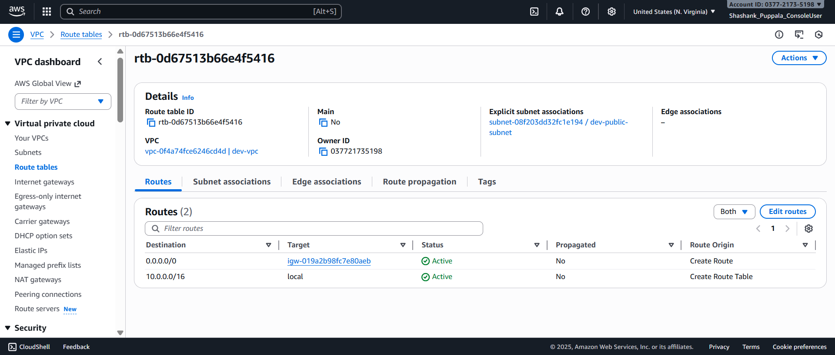

**Internet Gateway -**

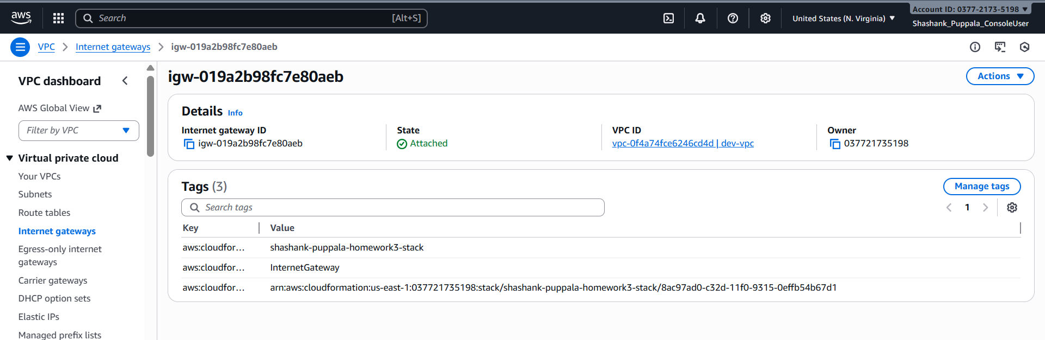

**Public Security Group -**

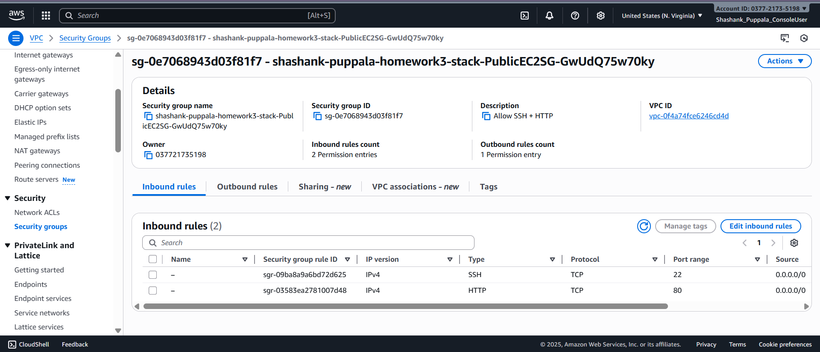

**EC2 Instance running in the public subnet -**

**EC2 -**

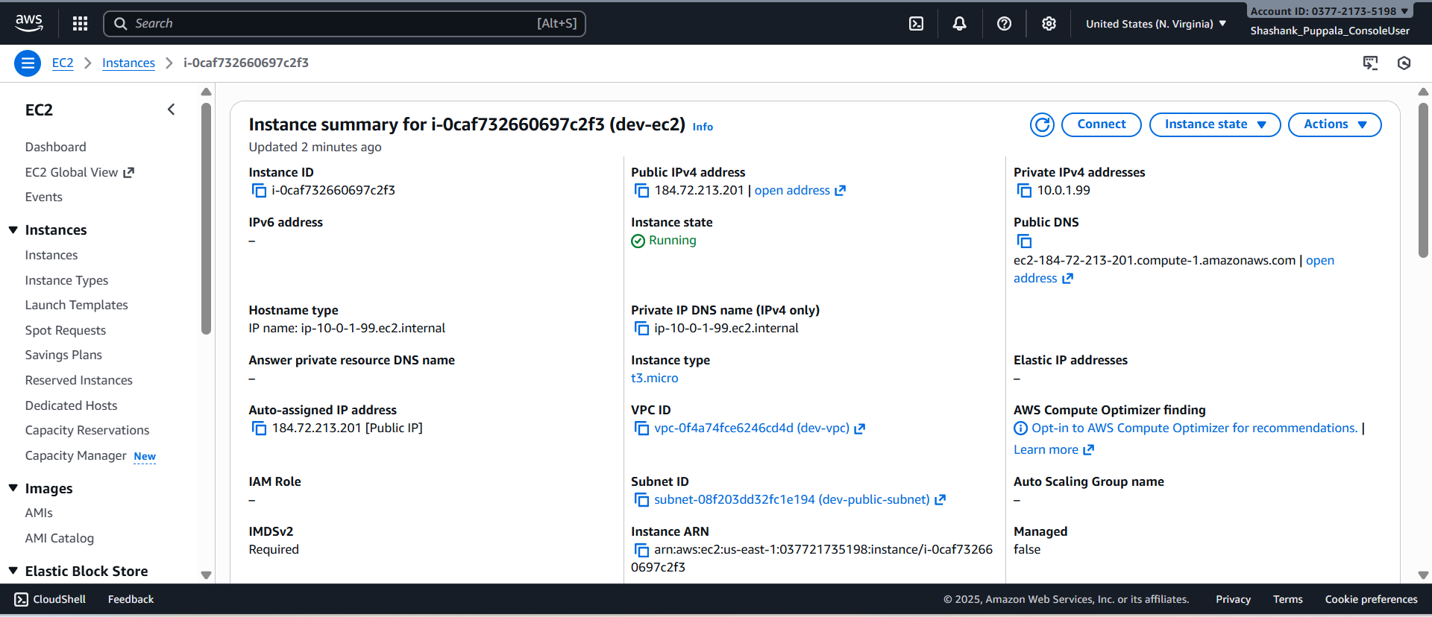

**S3 Bucket -**

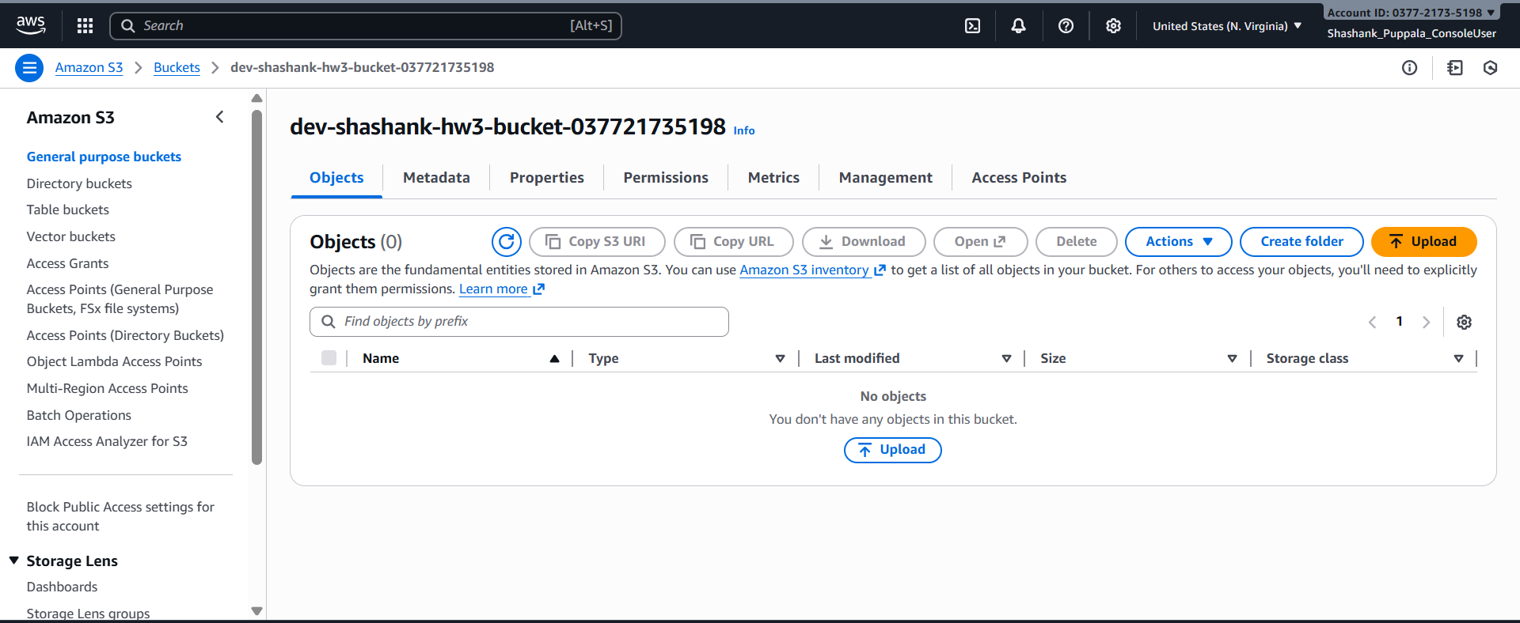

**Lambda function triggered by S3 object creation -**

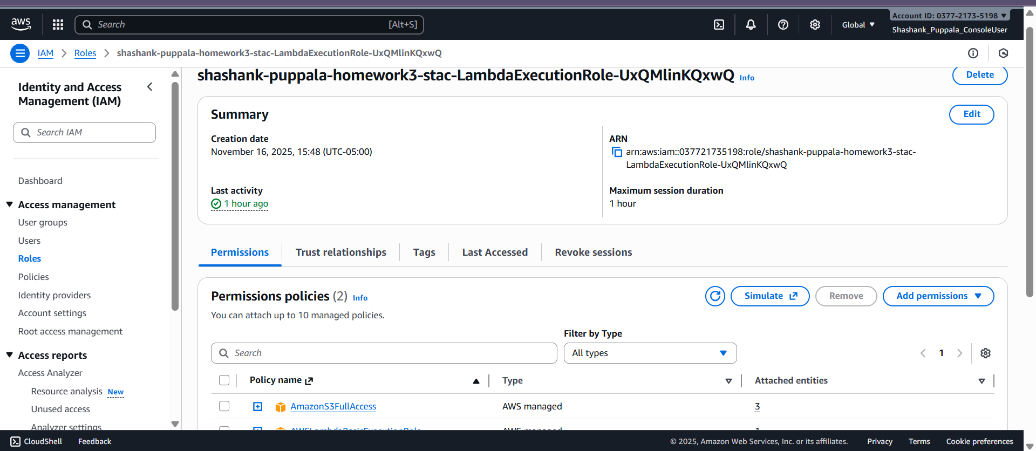

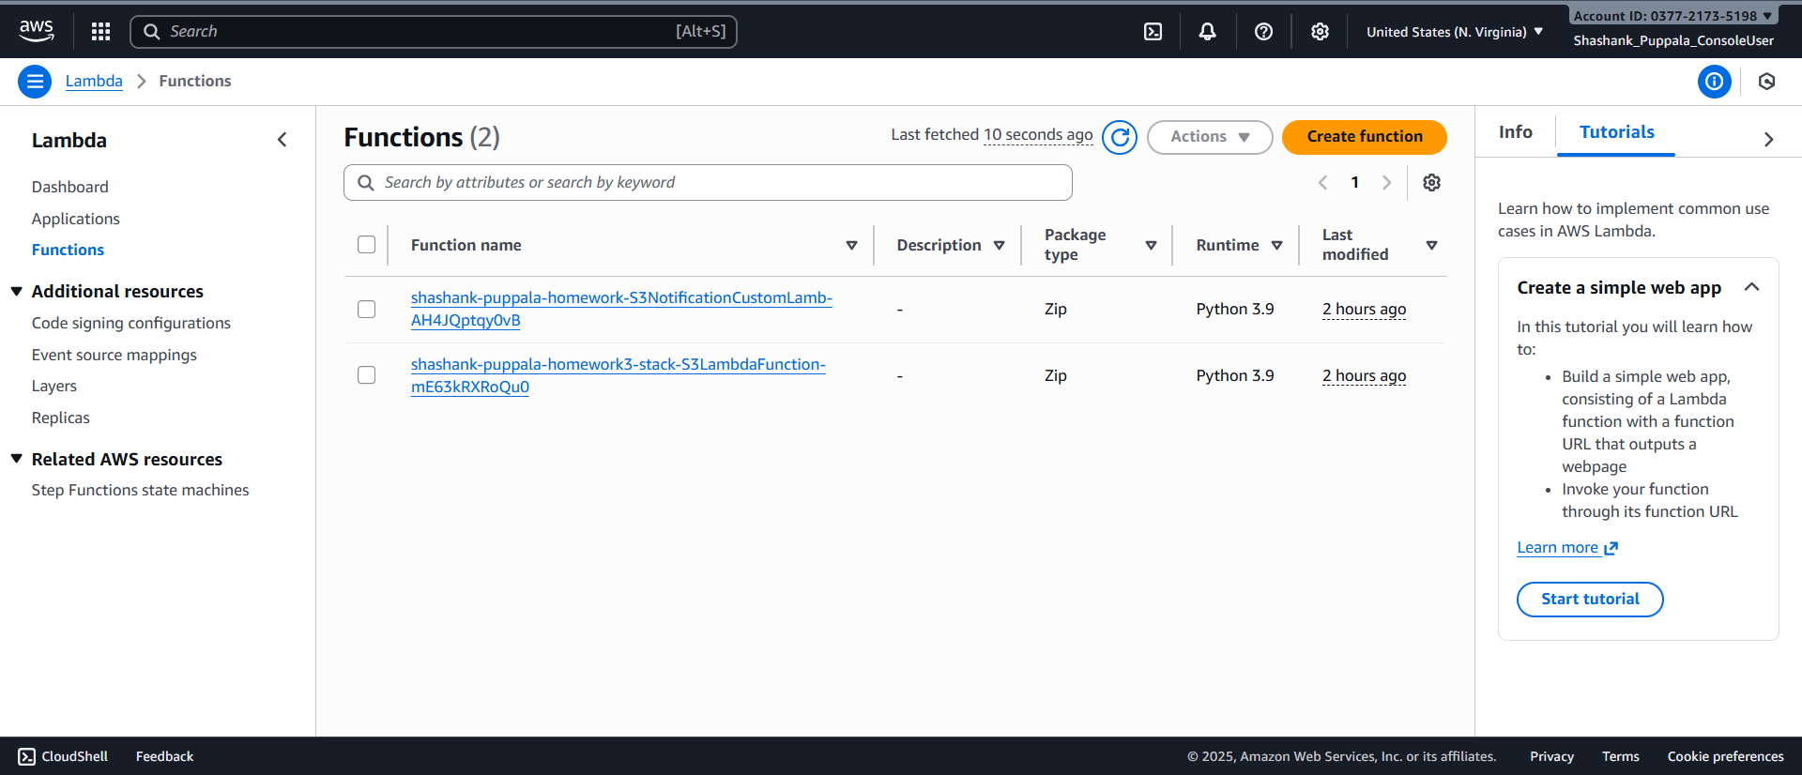

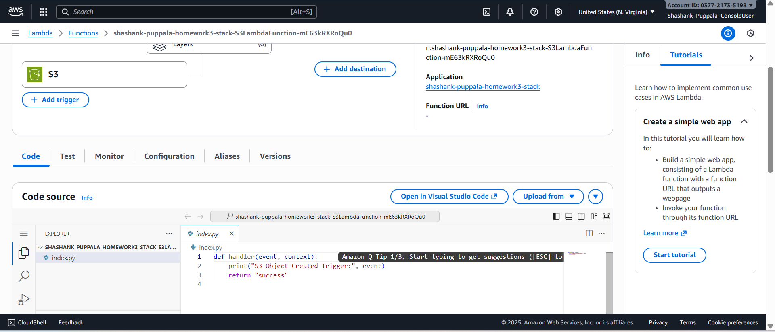

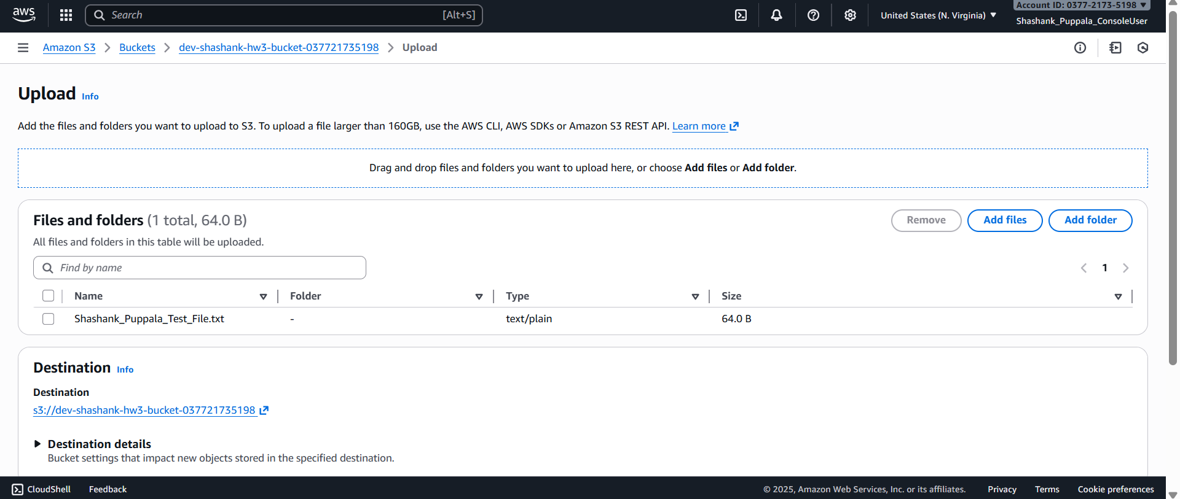

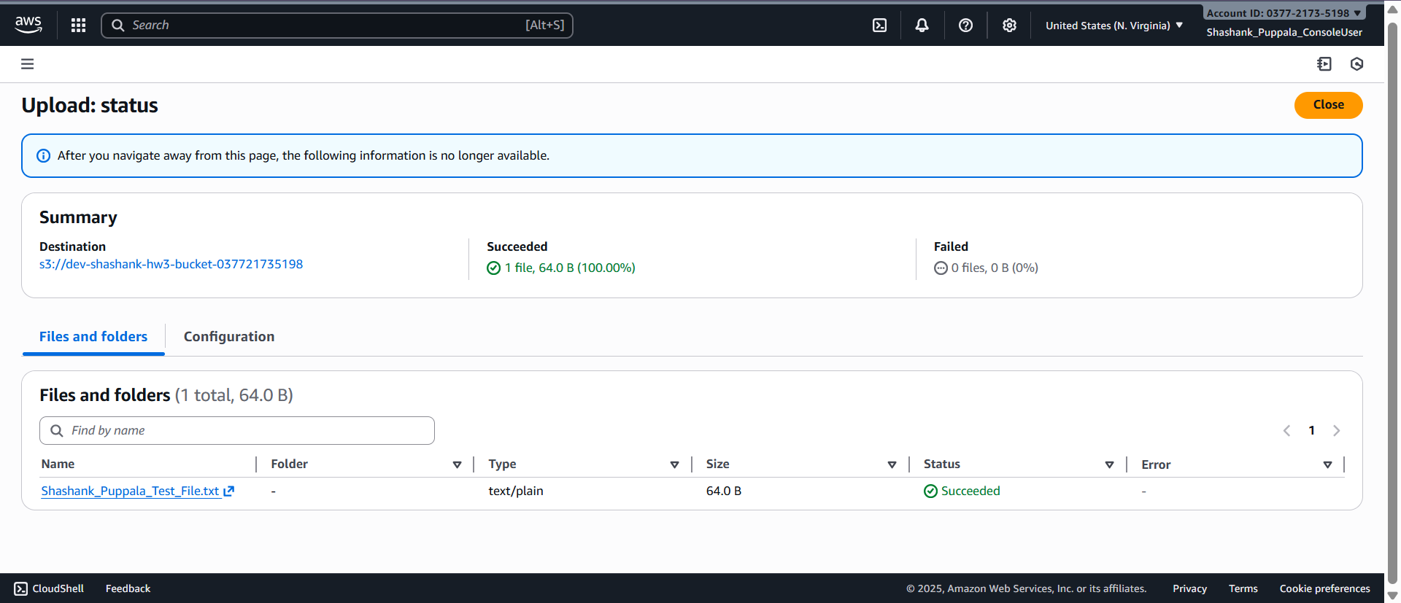

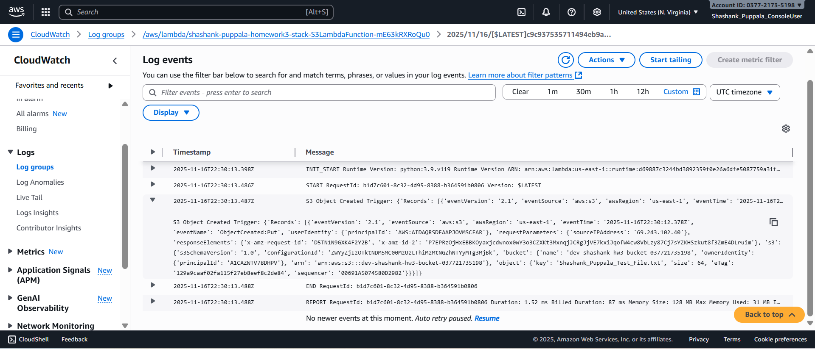

**By changing the Parameter value while deploying the template we can create the resources for the production environment as well;**

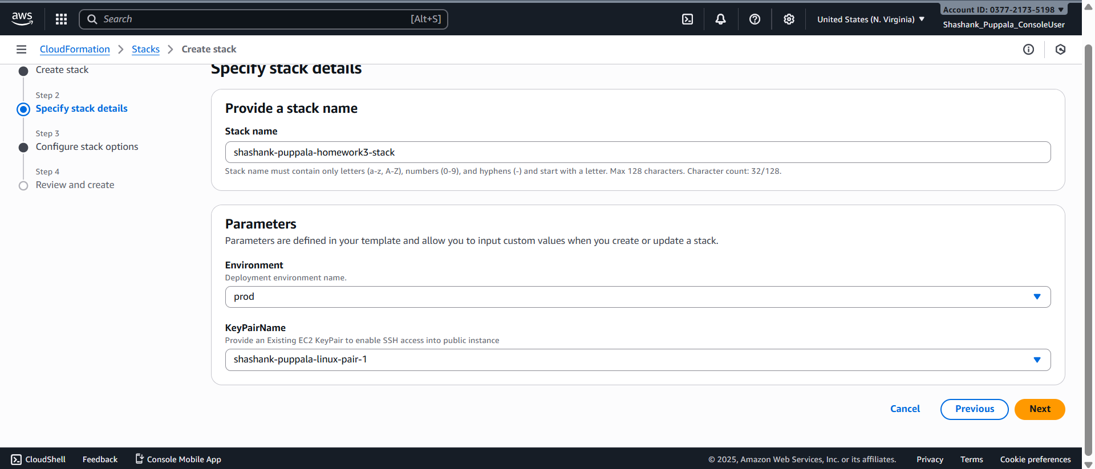

**Validating the resources created using AWS CLI and AWS Console -**

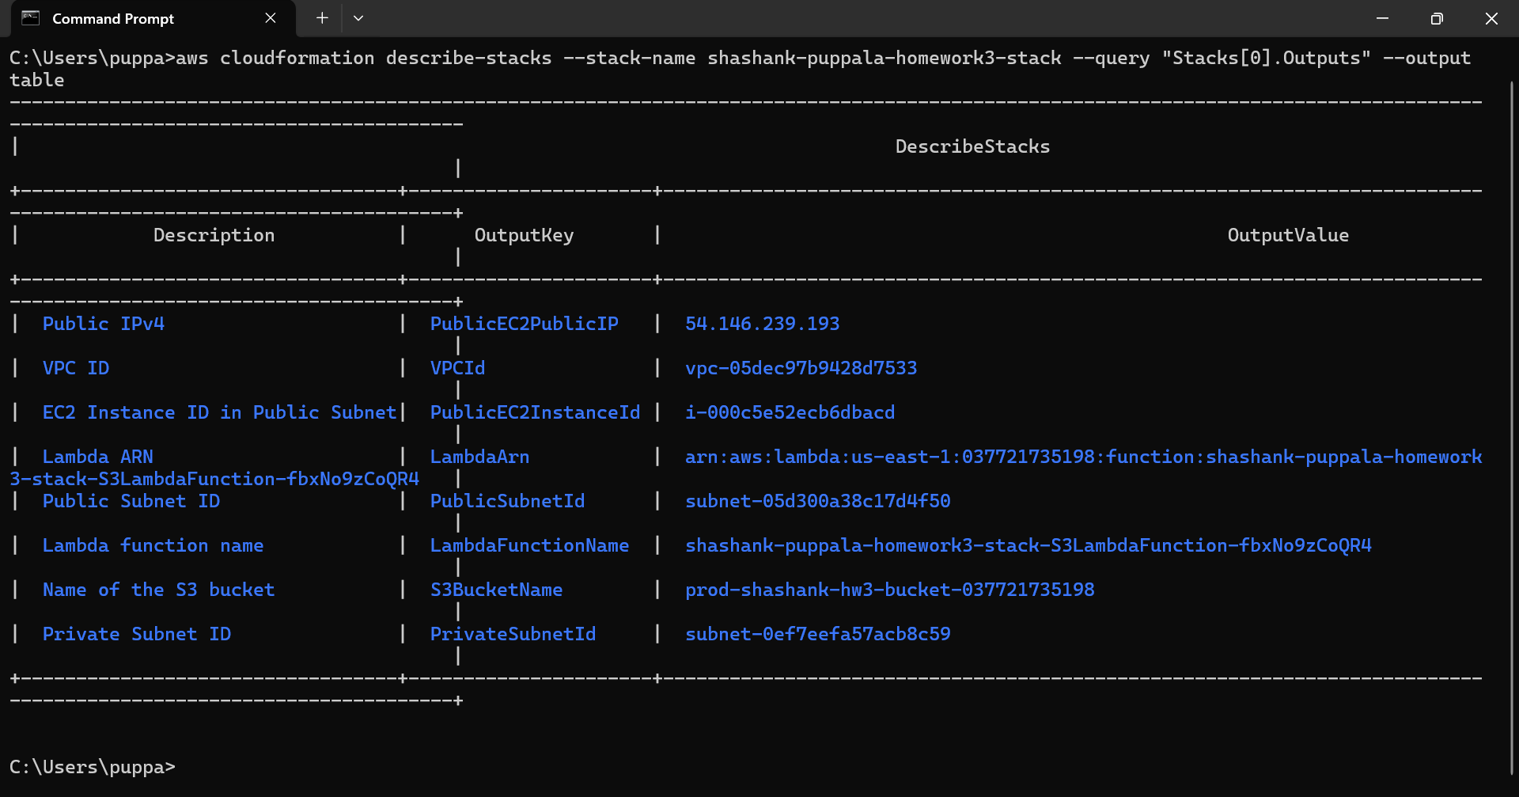

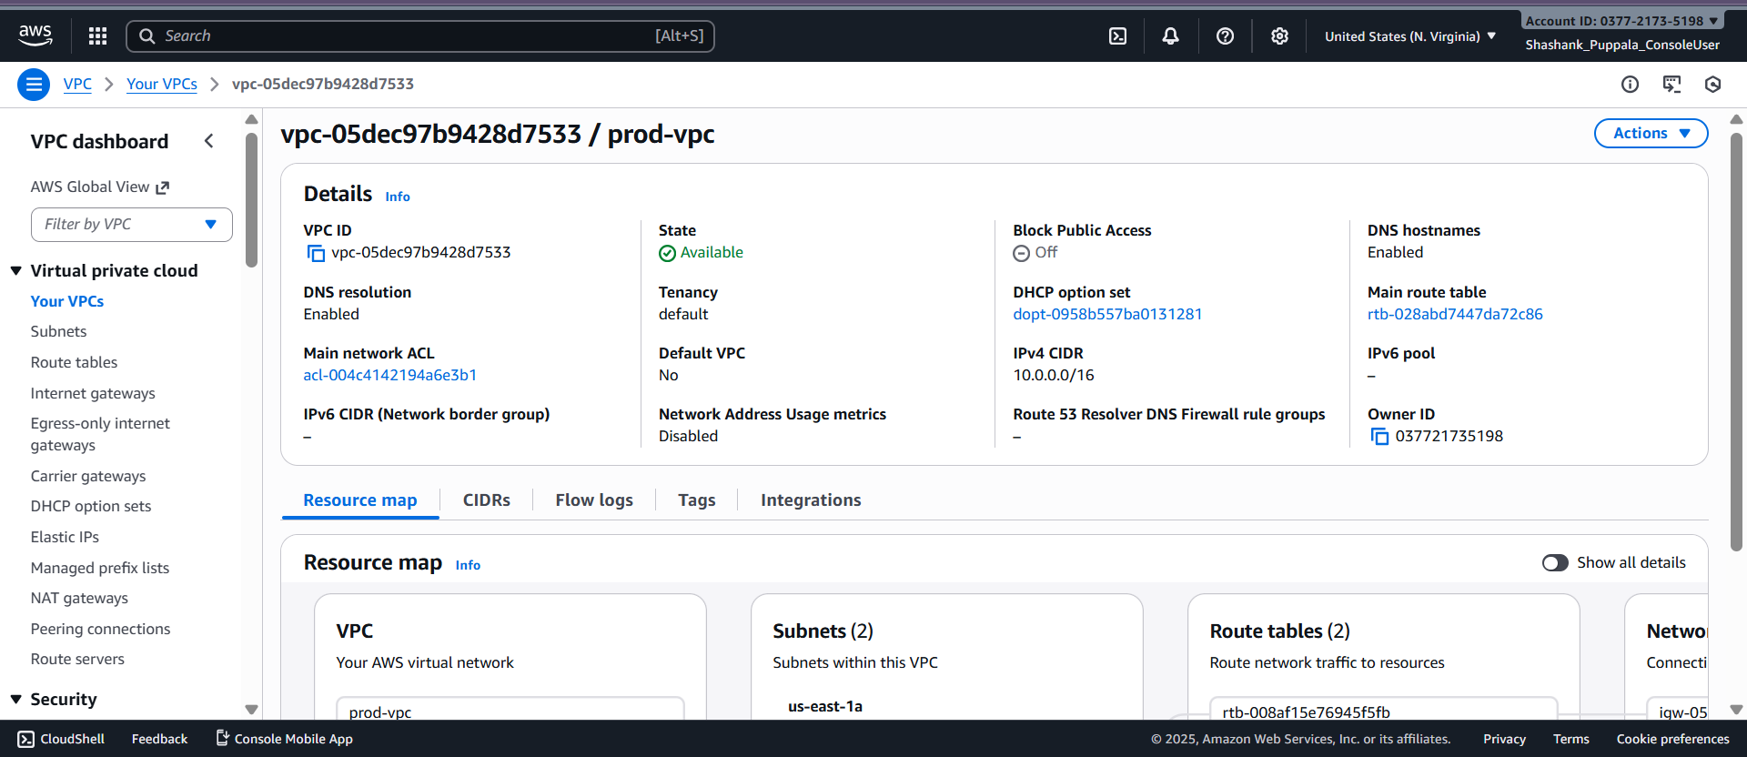

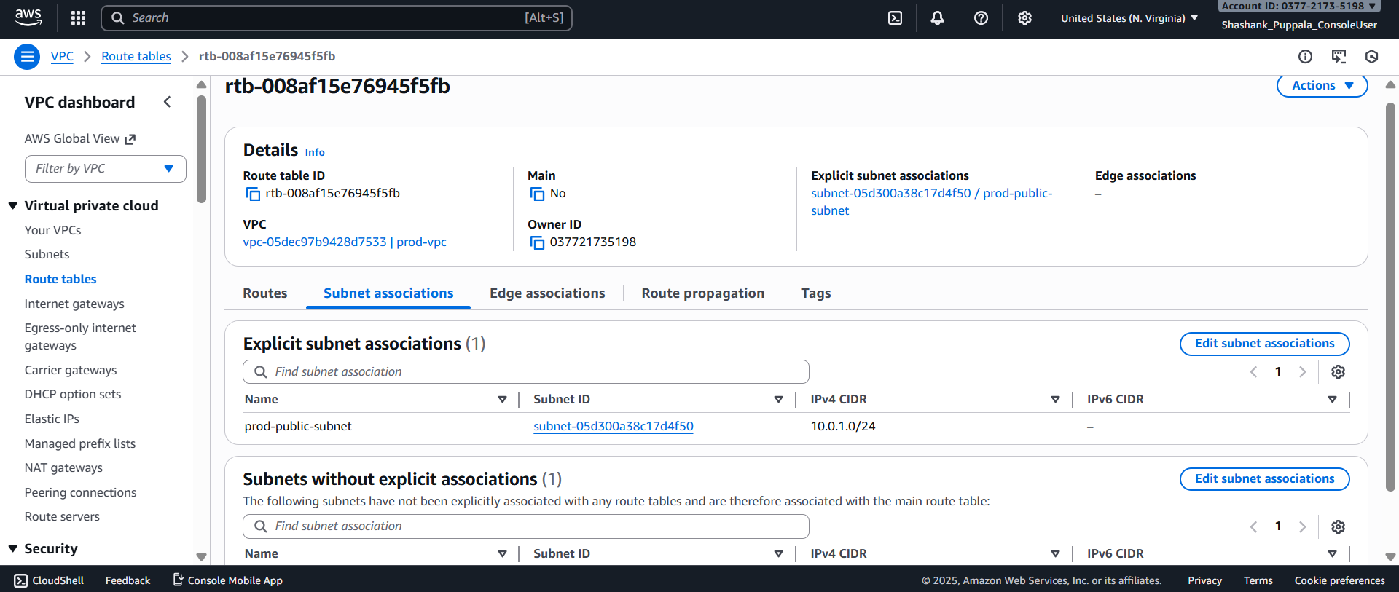

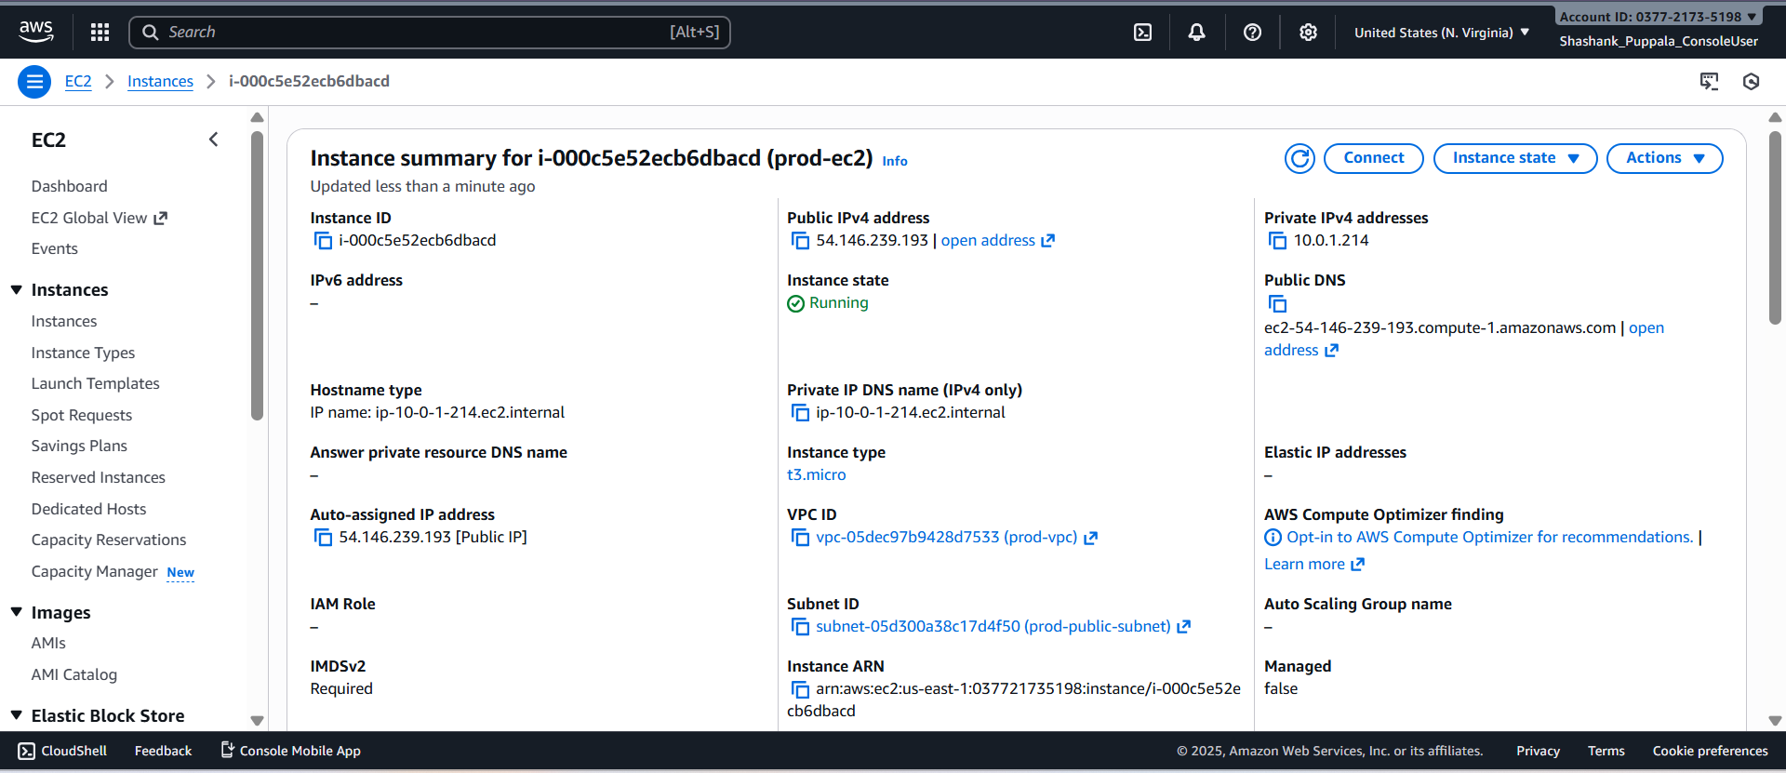

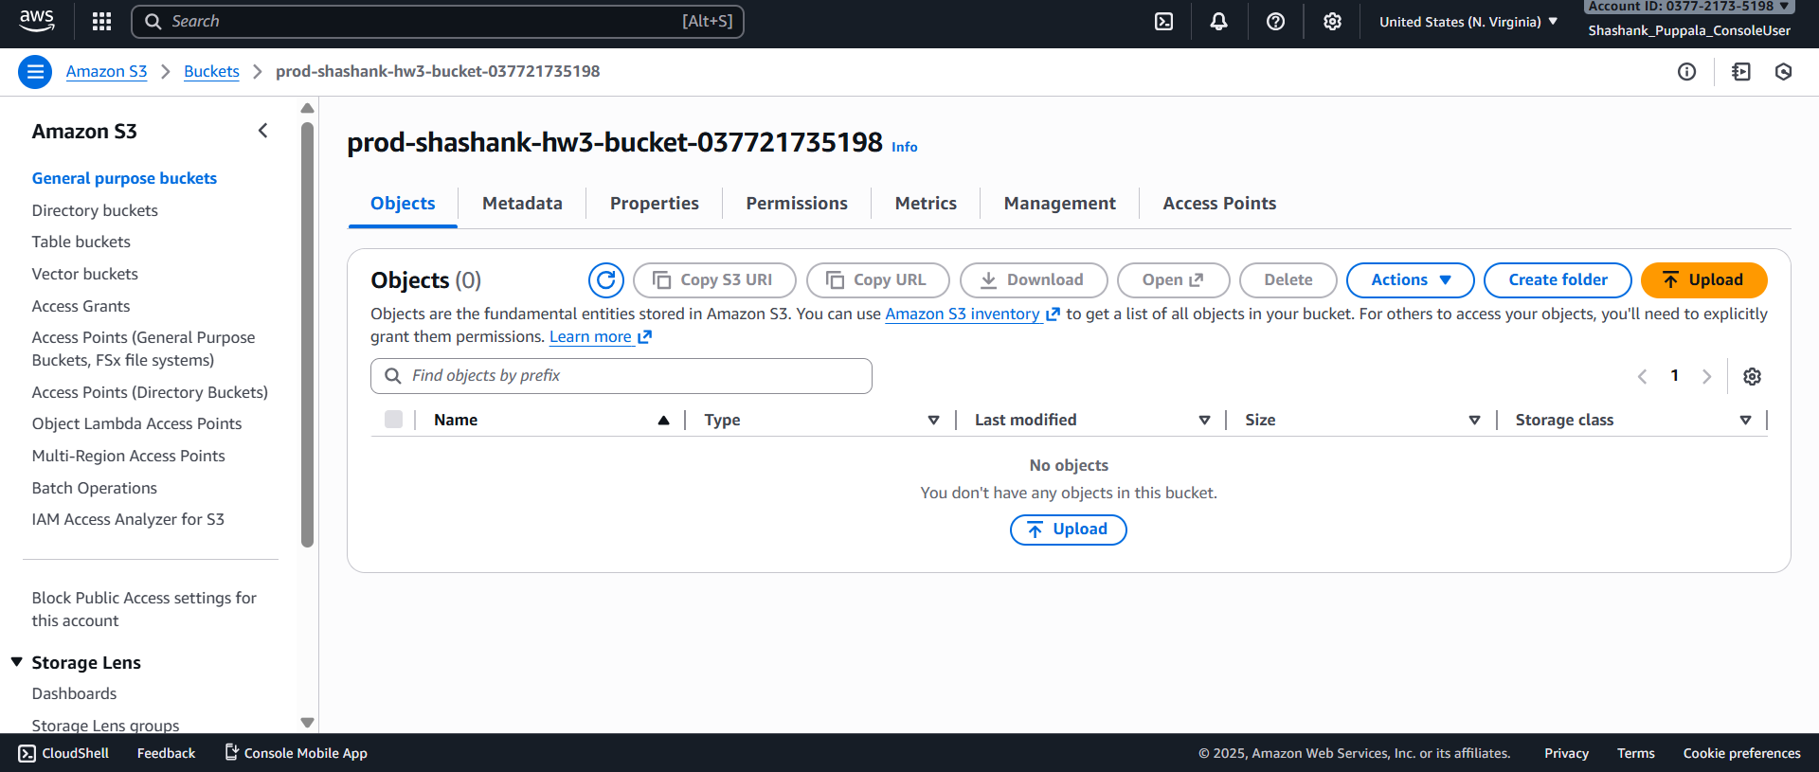

**Resources Used: -** The CloudFormation architecture which we used above has several resources used. So, what does each resource does in the architecture is as follows;

a. VPC - Created a custom VPC. All the resources defined such as EC2, subnets, and route tables stay live inside this custom VPC we created.

b. Public Subnet – Placed the EC2 instance created in this so that it can have internet access. It is associated with the public route table which is pointing towards the Internet Gateway.

c. Private Subnet – Can be used for the backend resources such as private instances which only need to be accessed privately but currently does not have any resources in it.

d. Internet Gateway – Attached to the VPC, so that the EC2 instance in the public subnet can have internet access.

e. Route table and Association – Associated the route table with the public subnet so that it can direct the traffic correctly.

f. EC2 Instance – Launched using CloudFormation in the public subnet and is running to perform the operations.

g. S3 Bucket – Created the bucket so that it can store the uploaded files. Here it is used to trigger the lambda function whenever a new file is uploaded into it.

h. Lambda Function – Consists of Python code that logs the uploaded file details and is triggered when a new file is uploaded to S3 bucket.

i. IAM Execution role – Exclusive role with AWS Lambda basic execution and S3 read only access. Allows lambda to write the logs to the cloud watch when triggered.

j. S3 Event Notification – Used to configure S3 to invoke the Lambda function when objects are created.

So, these are all the resources used in the CloudFormation architecture and what they do to support the necessary operations.

### **Part 2: AWS Lambda (15 points)**

#### **Task: Build and Trigger a Lambda Function**

* Create a simple **Lambda function** in Python that is triggered when a file is uploaded to a specific S3 bucket.
  + The function should log the file name and size to CloudWatch.
* Package and deploy the Lambda function using the **AWS CLI**.
* Attach the necessary **IAM role** with the right permissions.

**Sample Lambda Function (Python):**

import json

import logging

def lambda_handler(event, context):

for record in event['Records']:

bucket = record['s3']['bucket']['name']

key = record['s3']['object']['key']

size = record['s3']['object'].get('size', 'Unknown')

logging.info(f"New file uploaded to {bucket}: {key} (Size: {size})")

return {

'statusCode': 200,

'body': json.dumps('Lambda execution successful')

}

**Creation of IAM execution role for lambda functions execution -**

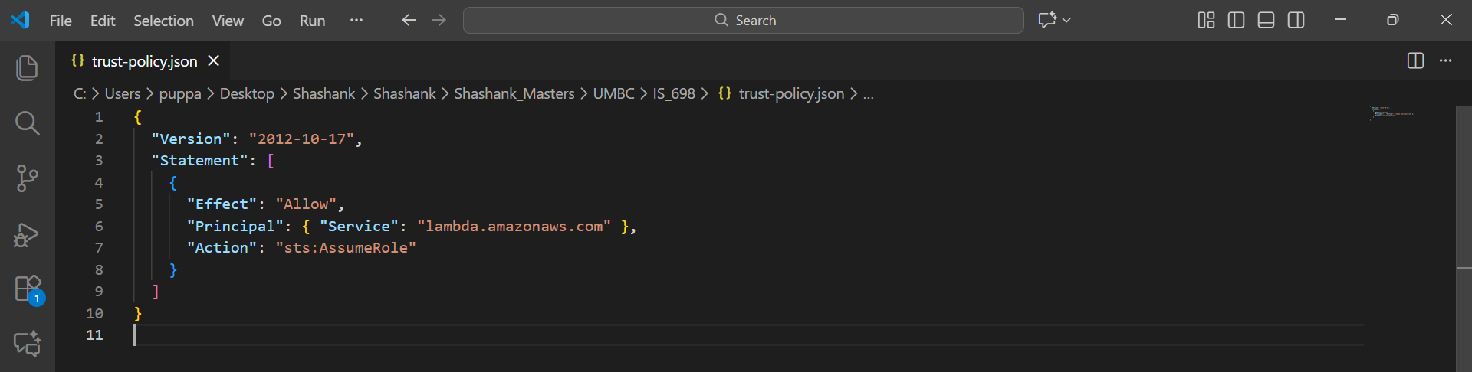

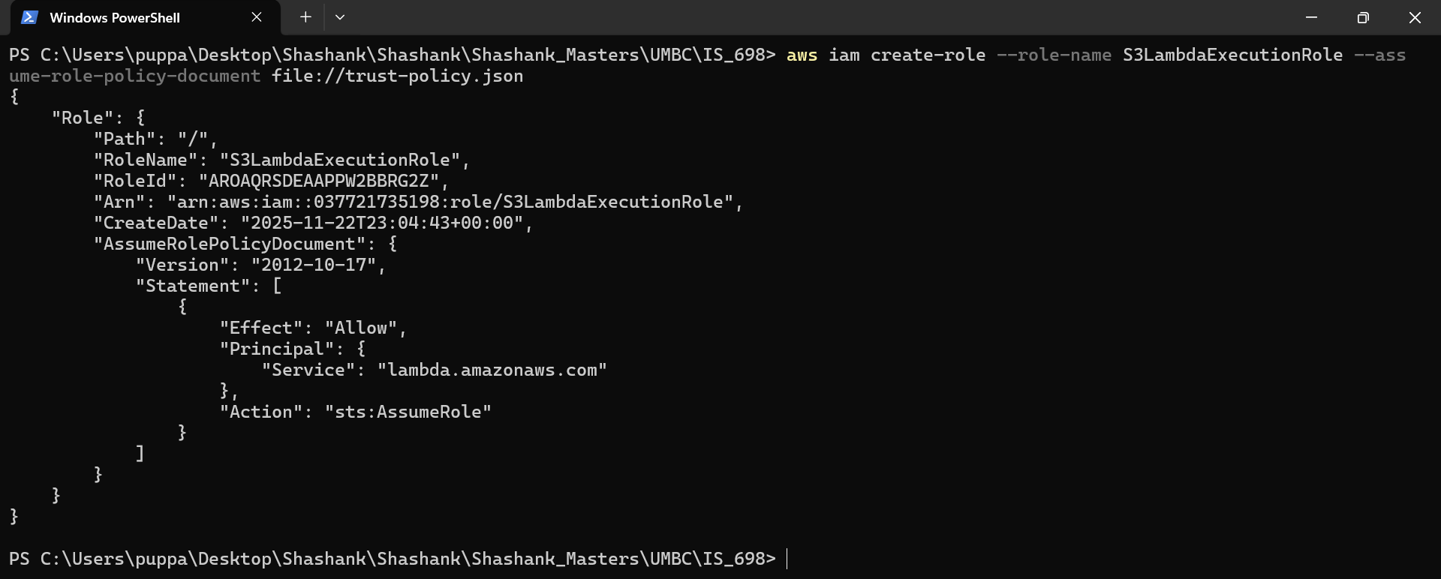

**Provide the IAM role with the necessary policies to execute the Lambda function and read the S3 bucket;**

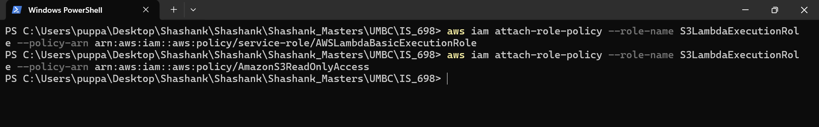

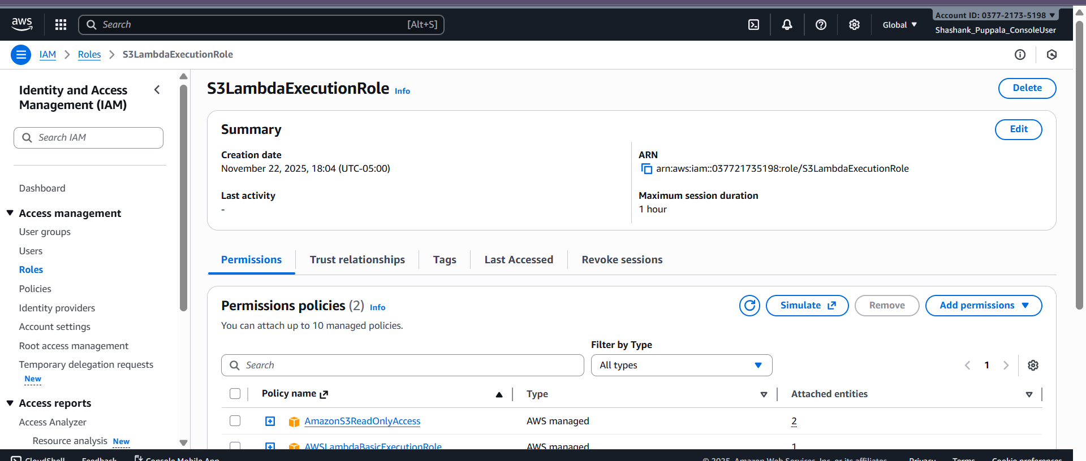

**Sample lambda function in python triggered when a file is uploaded to S3 bucket**

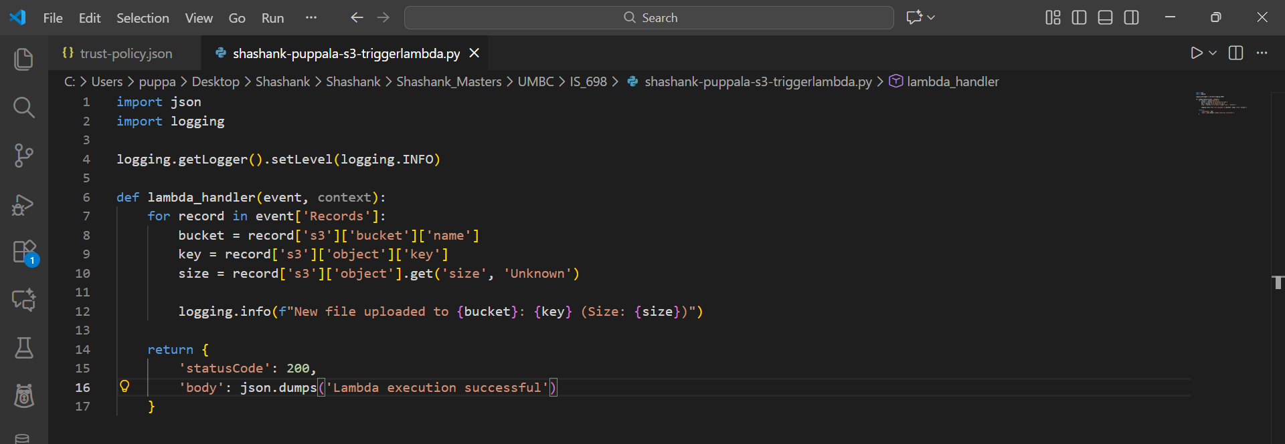

Add the python file into the zip folder and deploy it to the AWS cloud;

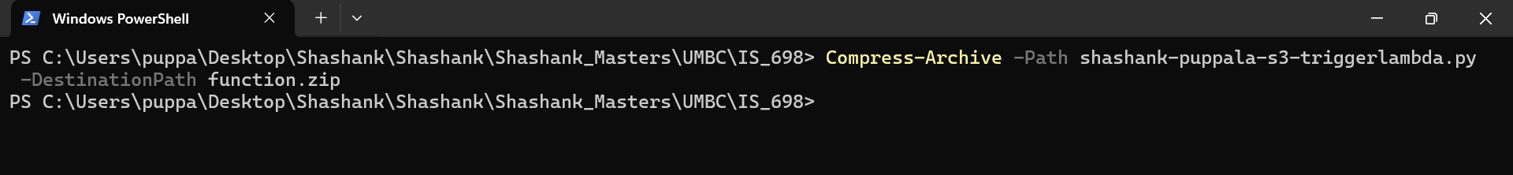

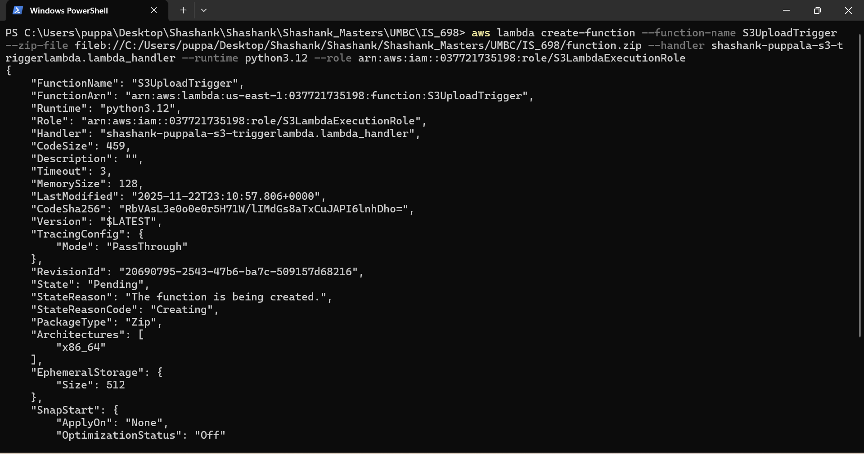

Verify in the AWS console after the function is deployed from CLI and check if the execution role is attached to the function -

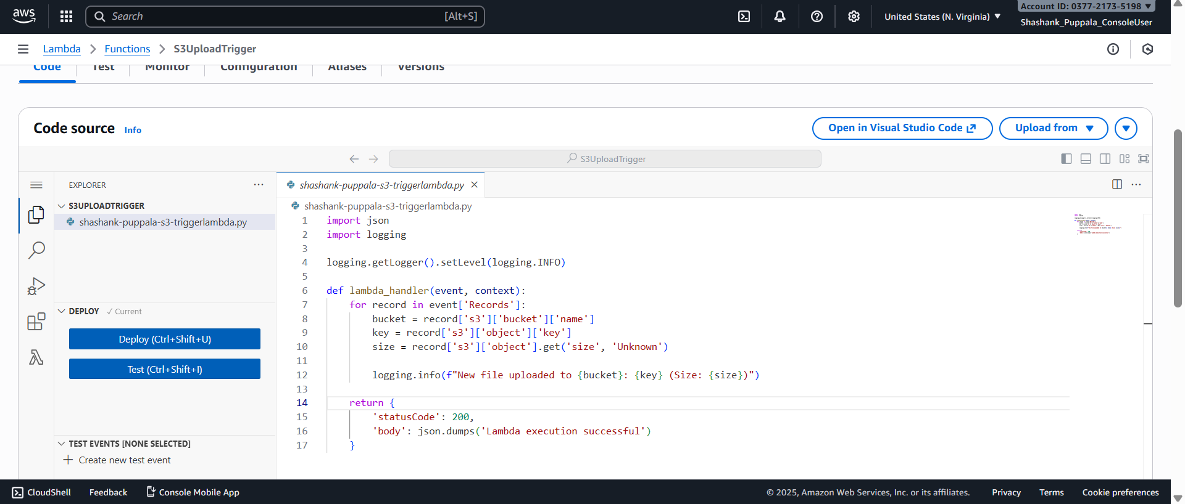

Once after the function is successfully deployed and verified, created the S3 bucket;

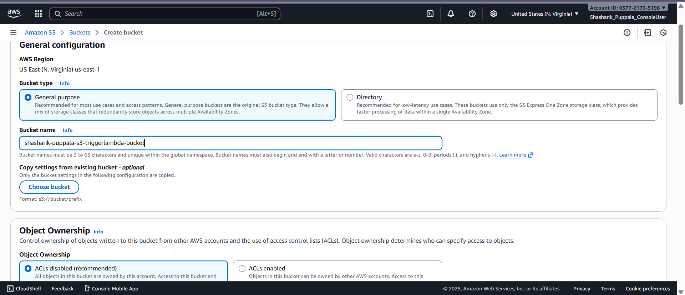

Created the permission for S3 to invoke the lambda function;

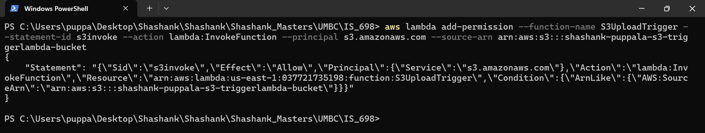

Event Notification from S3 -

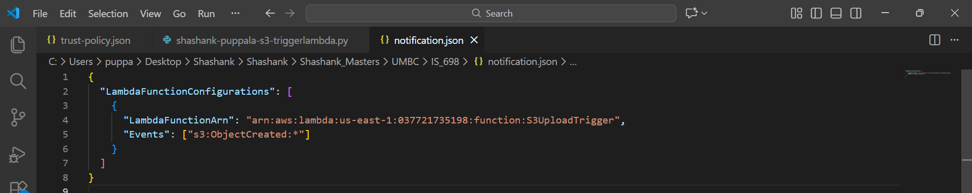

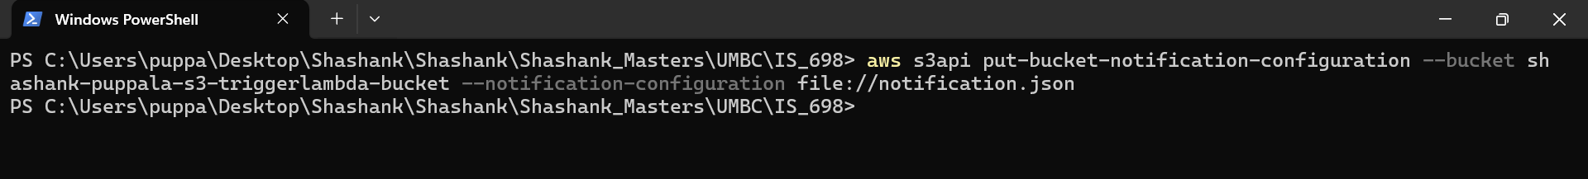

**Once everything is aligned, we can upload a test file into S3 bucket to check whether it is triggering the lambda function;**

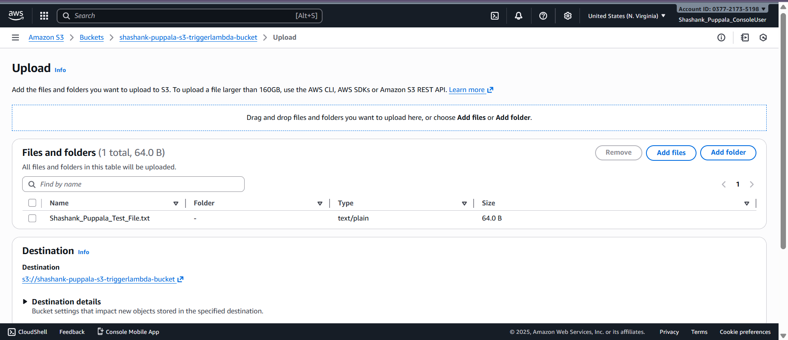

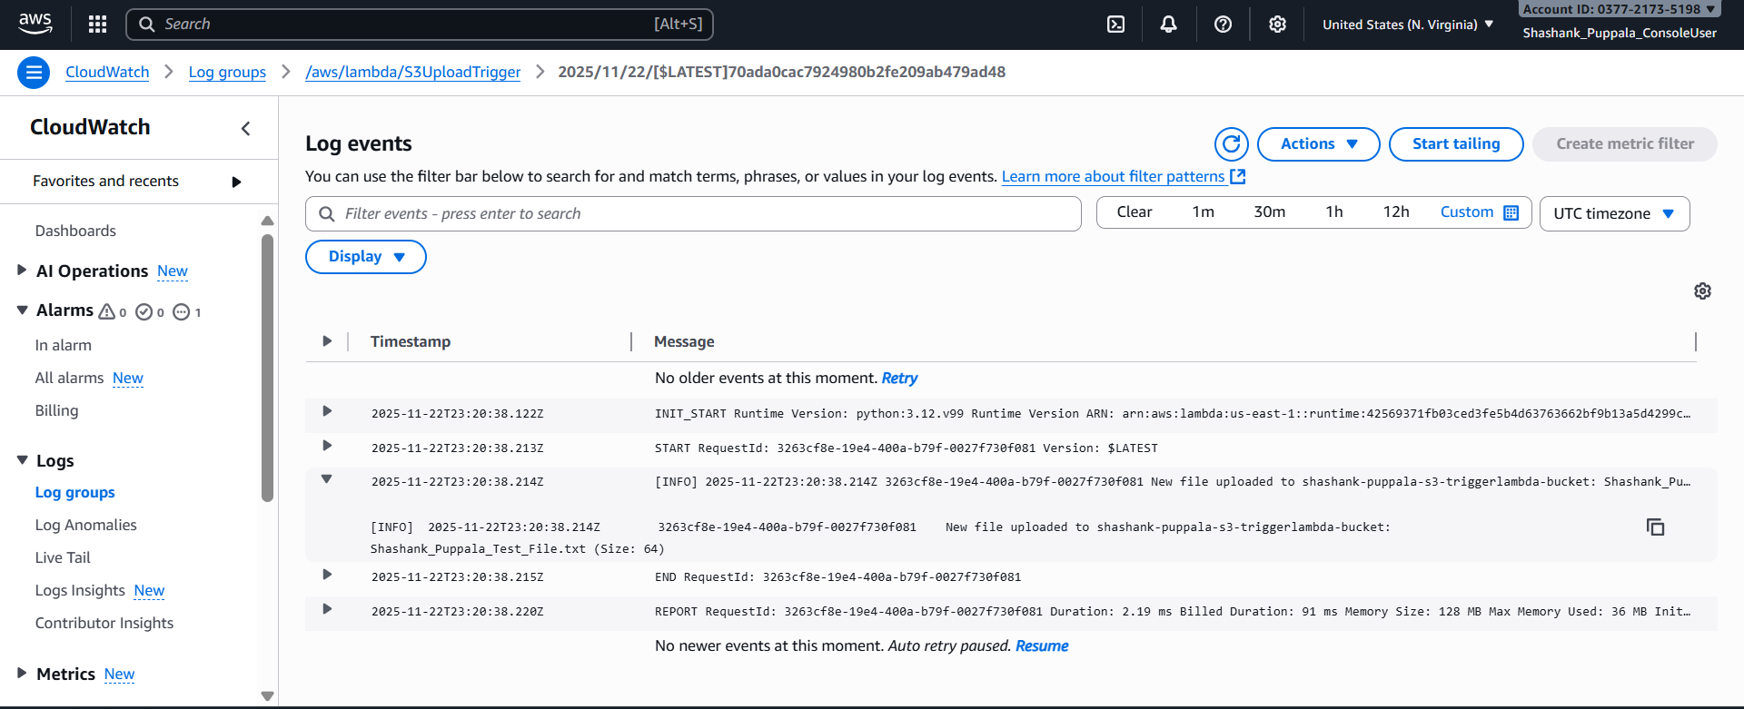

Can check with one another example as well;

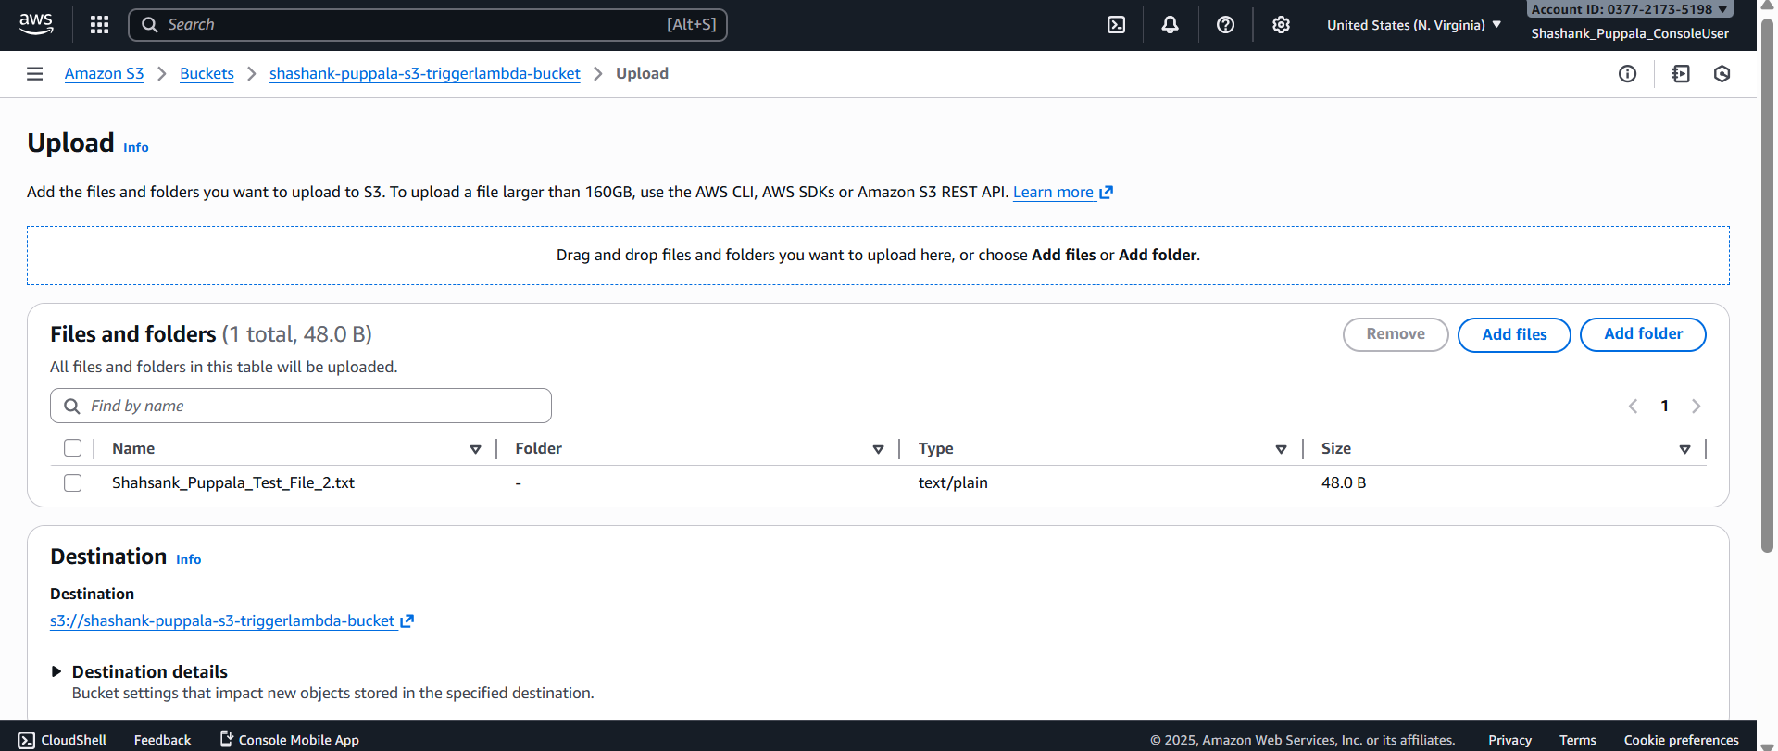

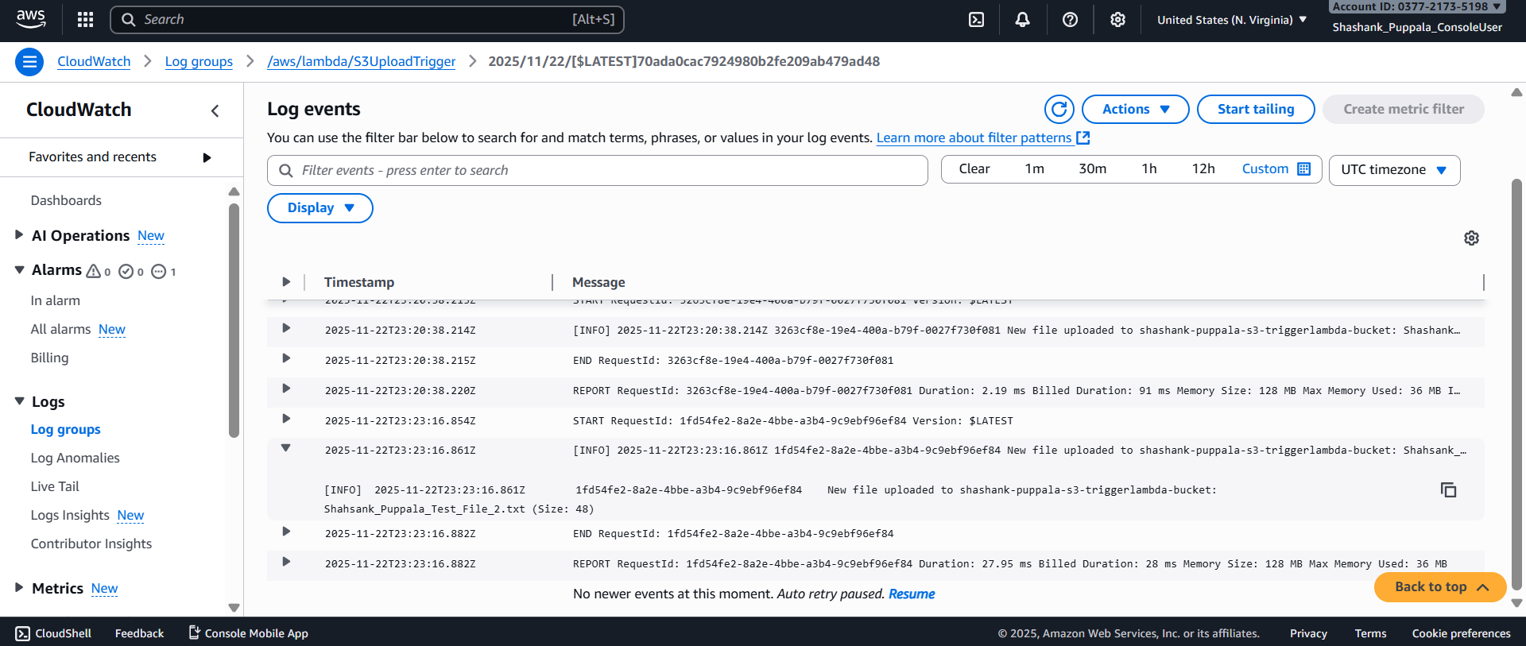

**CLI commands Used: -** There are several CLI commands used in this part as follows;

a. **aws iam create-role --role-name <role-name> --assume-role-policy-document <file_name>** -- This command creates a new IAM role which lambda assumes to execute the function.

b. **aws iam attach-role-policy --role-name <role-name> --policy-arn <policy-permission>** -- This command is used to attach the necessary policies to the role. This will make sure the role has the least privilege access, while still having the necessary permissions to perform the required tasks.

c. **Compress-Archive -Path lambda_function.py -DestinationPath function.zip** - This command packages your python code into a ZIP file for lambda deployment. As Lambda accepts only .zip file format when using CLI, it's required to deploy the code in zip format only.

d. **aws lambda create-function --function-name S3UploadTrigger --runtime python3.12 --role arn:aws:iam:::role/S3LambdaExecutionRole --handler lambda_function.lambda_handler --zip-file fileb://function.zip** - Command used to create the lambda function in the AWS. Here in this command, we specify the role, which is to be used to run the code, runtime version, and specify what has to be run inside the code.

e. **aws lambda add-permission --function-name S3UploadTrigger --statement-id s3invoke --action "lambda:InvokeFunction" --principal s3.amazonaws.com --source-arn <source-arn>** - Grants S3 permission to invoke the lambda function.

f. **aws s3api put-bucket-notification-configuration --bucket --notification-configuration '{"LambdaFunctionConfigurations":[{"LambdaFunctionArn":"arn:aws:lambda:us-east-1::function:S3UploadTrigger","Events":["s3:ObjectCreated:*"]}]}'** -- Command tells s3 to invoke the lambda function whenever a new file is uploaded.

So, these are the CLI commands used in the CLI for deployment.

### **Part 3: AWS CLI Proficiency (10 points)**

#### **Task: Perform Common AWS Operations using AWS CLI**

* Use the CLI to perform the following tasks:
  + List all S3 buckets in your account

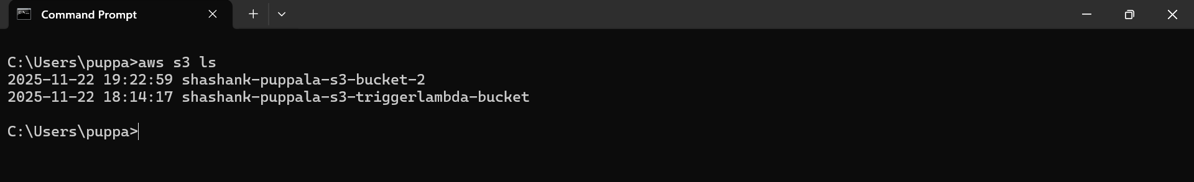

Create a new S3 bucket and upload a file

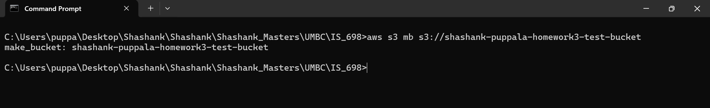

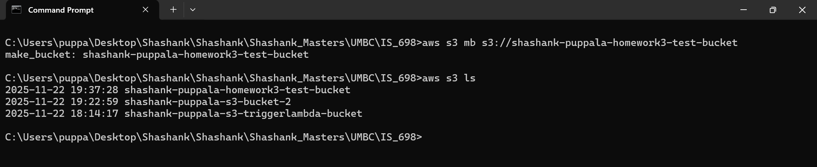

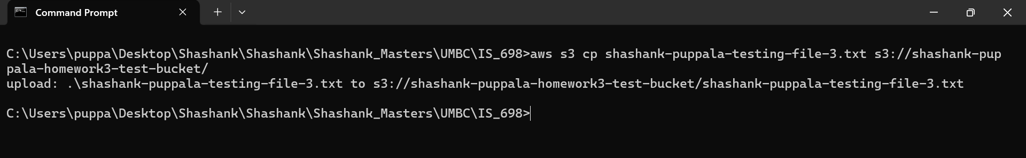

Check whether the file is successfully uploaded into the bucket or not;

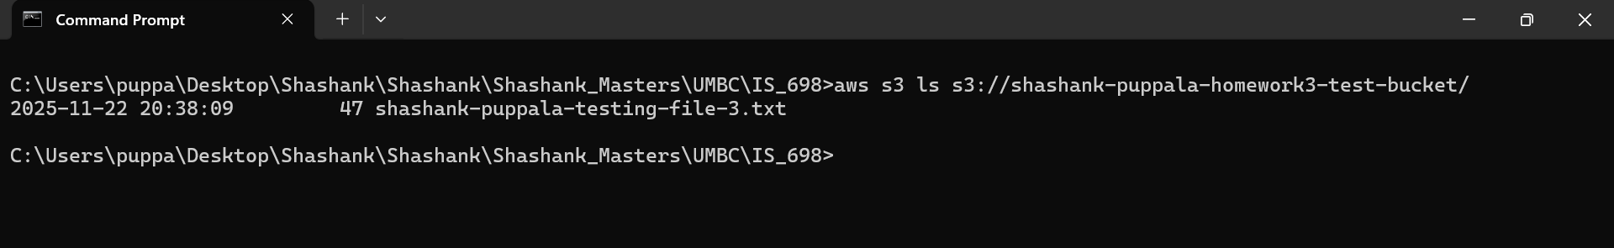

Verify in the Console as well whether the bucket has the uploaded file or not;

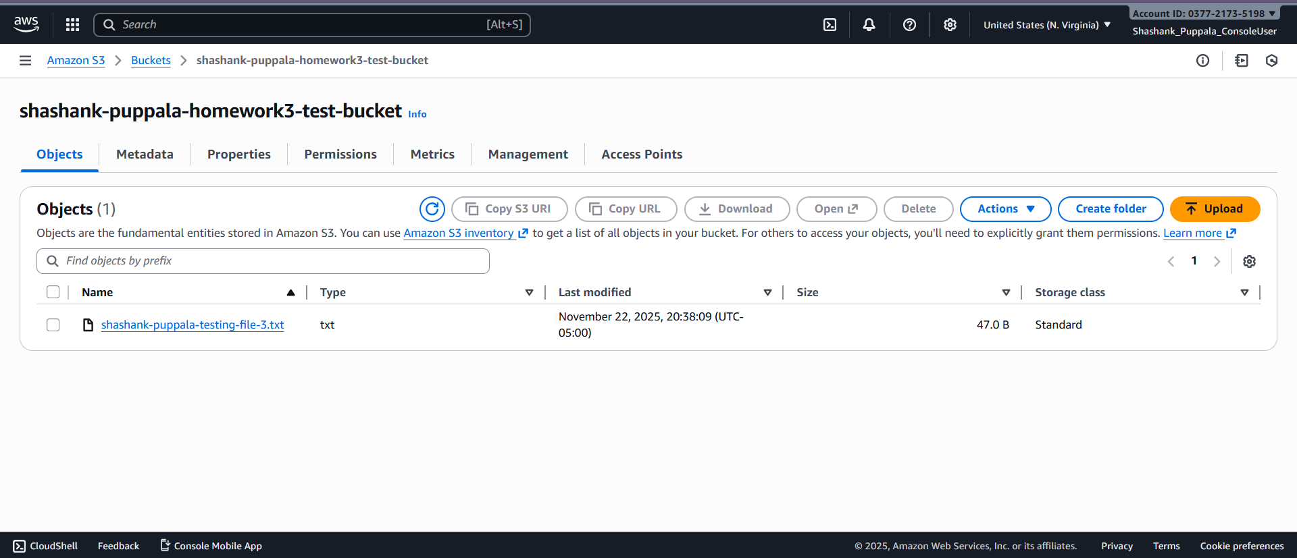

Start and stop an EC2 instance

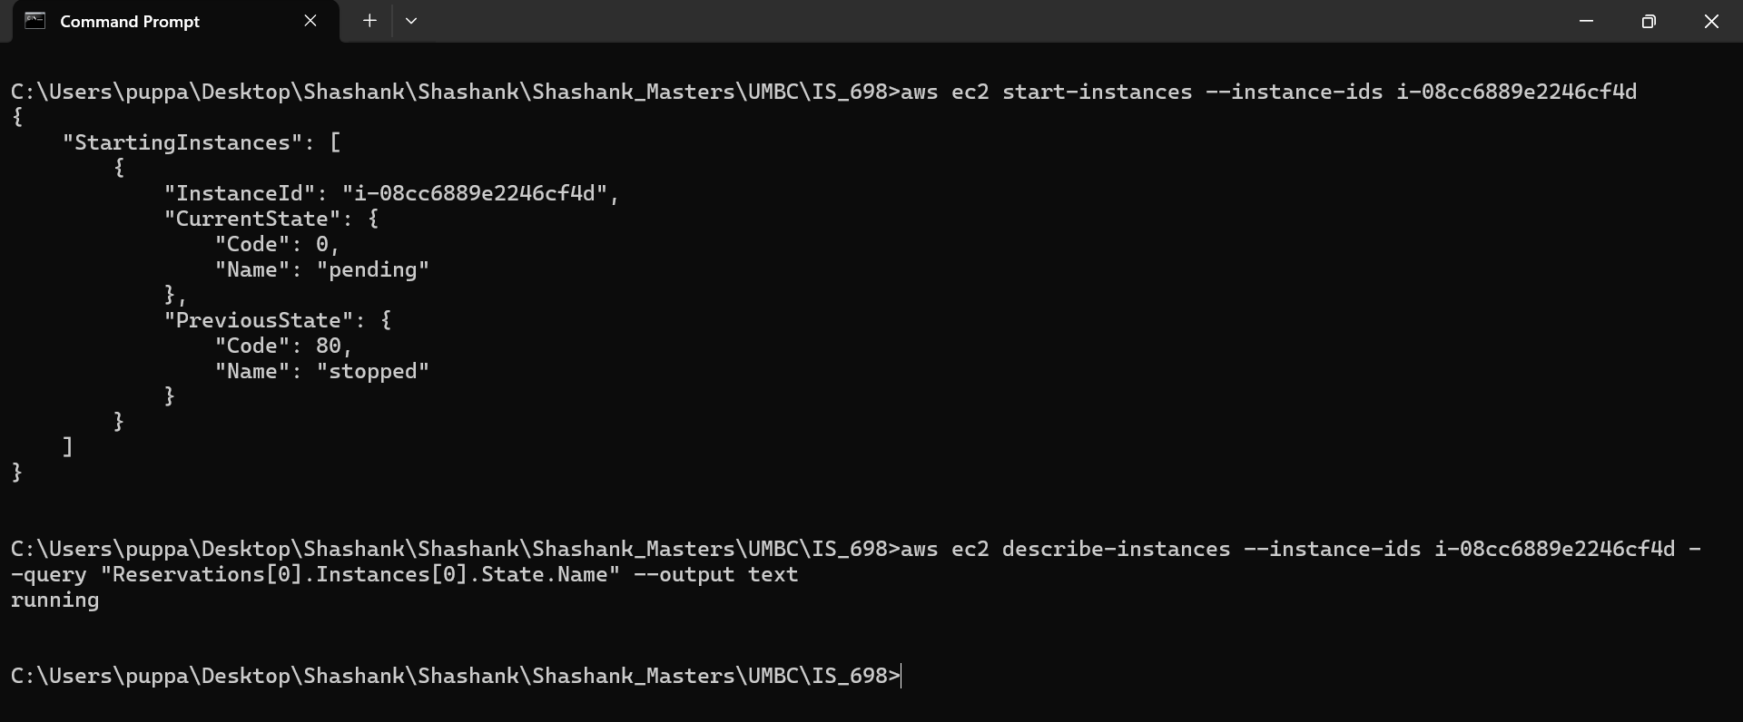

Verify in the Console if the instance started running;

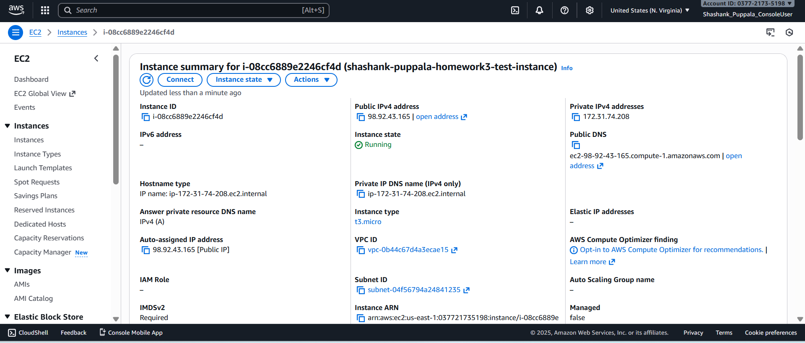

Stopping the Instance -

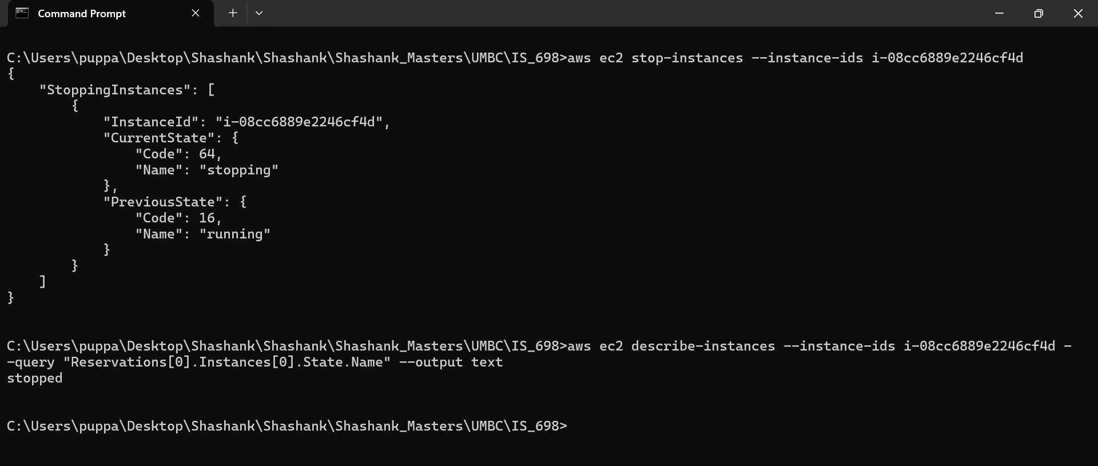

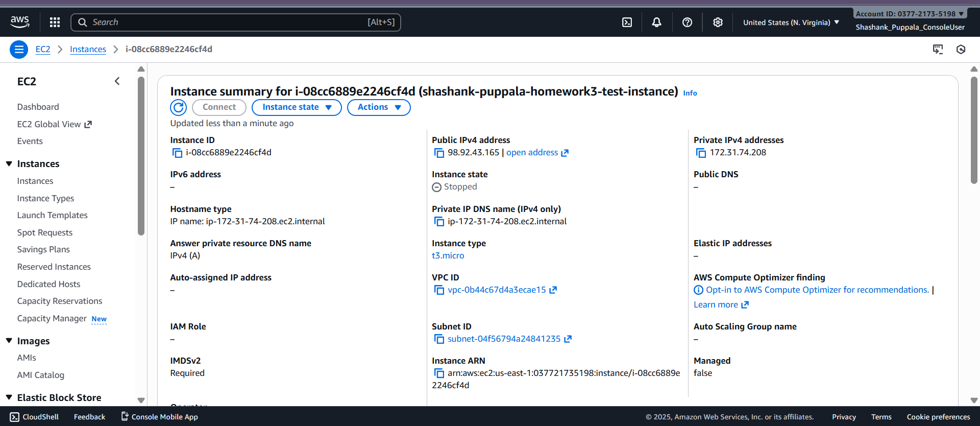

Retrieve logs from a Lambda function

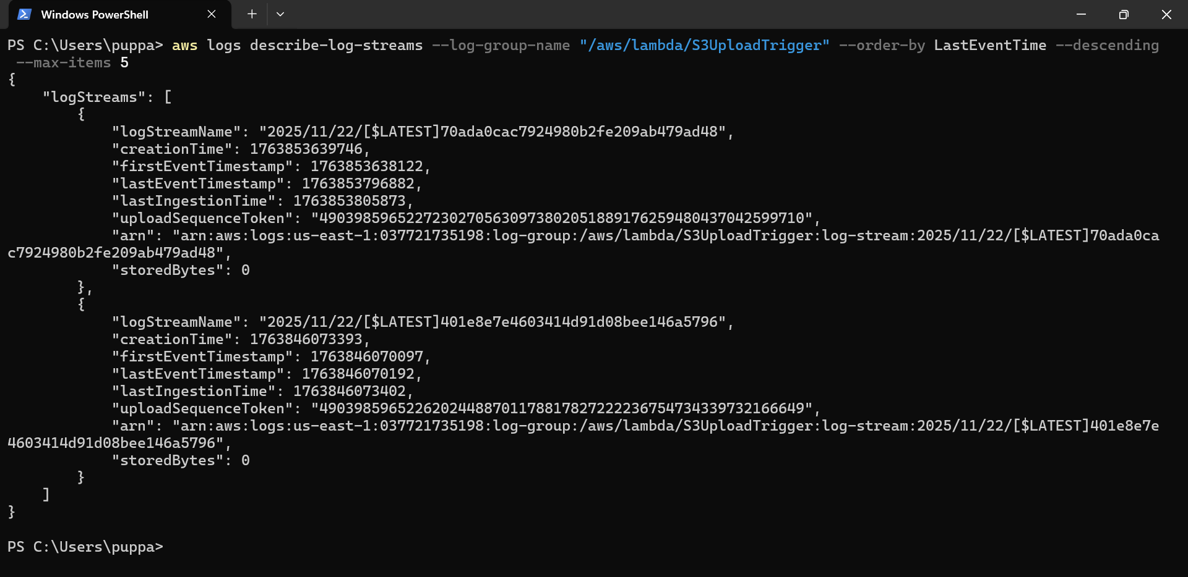

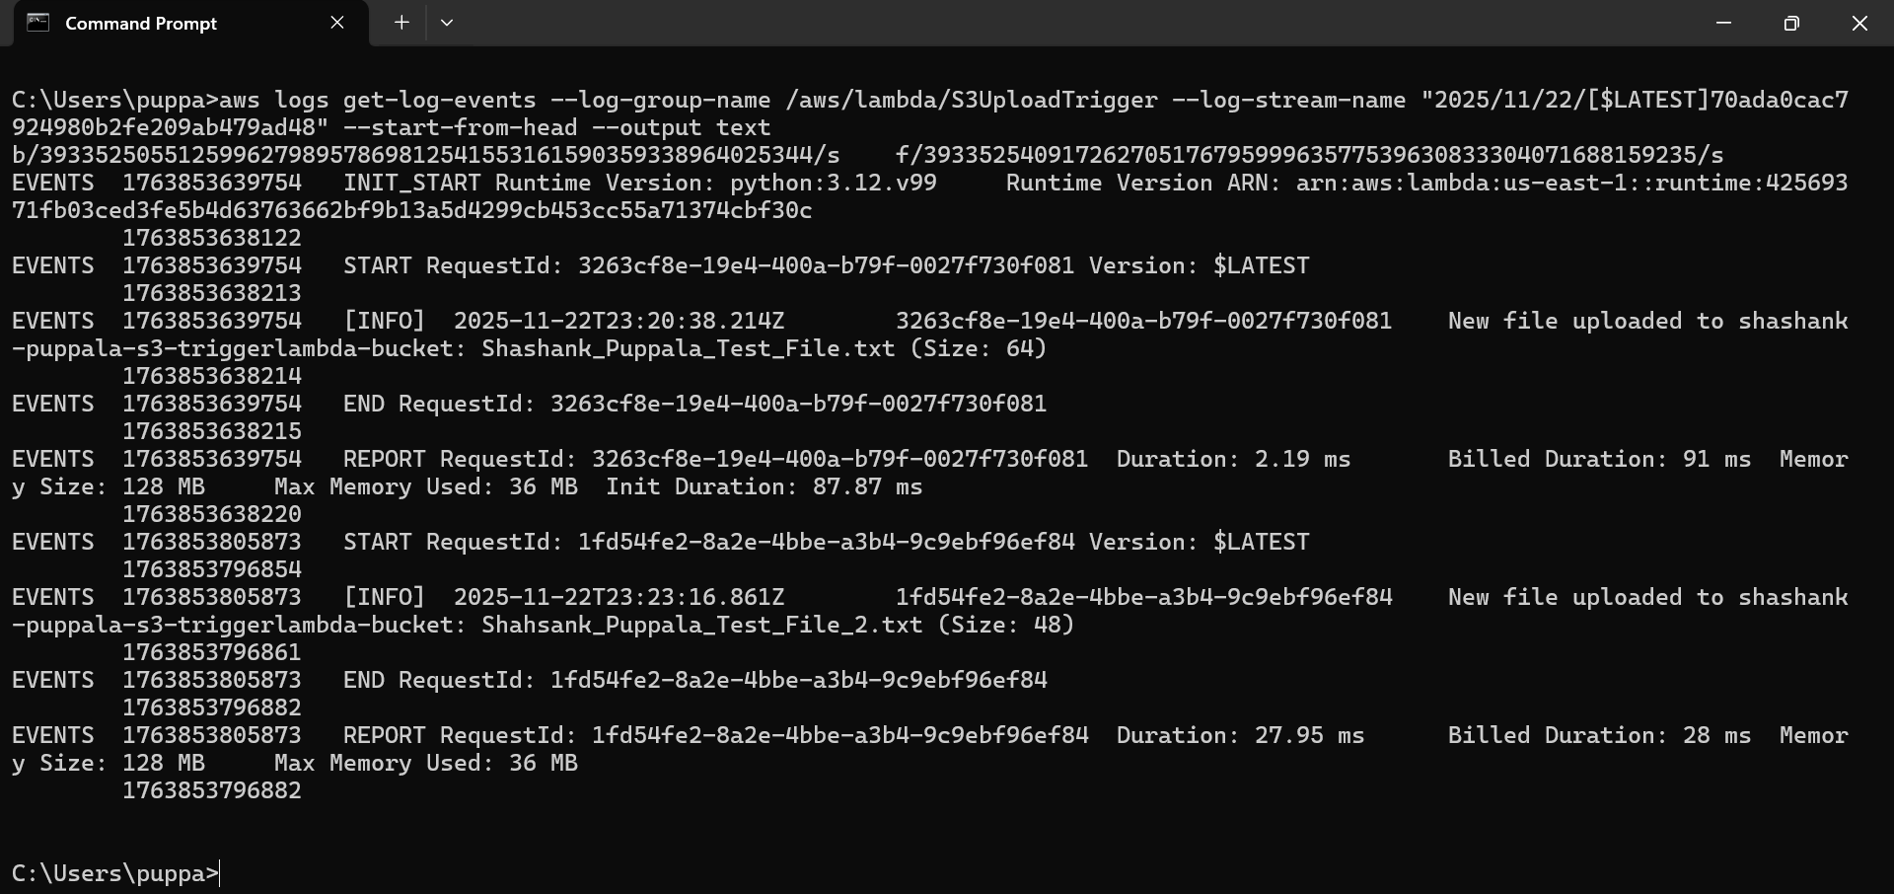

**Commands: -** Following are the CLI commands used for the above operations;

a. **aws s3 ls** – This command lists all the S3 buckets present in the AWS account.

b. **aws s3 mb s3://<bucket-name>** - This command will make or create the the S3 bucket with the given name.

c. **aws s3 cp test_file.txt s3://<bucket-name>** - Uploads the test file into the S3 bucket provided.

d. **aws ec2 start-instances --instance-ids <instance_id>** - Starts the instance in the AWS account.

e. **aws ec2 stop-instances --instance-ids <instance_id>** - Stops the instance which is running the AWS account.

f. **aws logs describe-log-streams --log-group-name /aws/lambda/S3UploadTrigger** - This will describe all the log streams that are present in the lambda’s CloudWatch log group.

g. **aws logs get-log-events --log-group-name /aws/lambda/S3UploadTrigger --log-stream-name <latest_logstream_name>** - Fetches the actual log entries created for the lambda function execution. Shows all the print logs, event inputs, and even the error logs if anything occurred.

**Part 4: Boto3 Scripting (5 points)**

#### **Task: Use Python Boto3 to Interact with AWS Services**

* Write a **Python script using Boto3** to:
  + List all files in a specified S3 bucket
  + Create a DynamoDB table
  + Insert an item into the DynamoDB table

Python script consisting of Code to list all the files in the specific S3 bucket, creating a DynamoDB, and inserting an item into the created table;

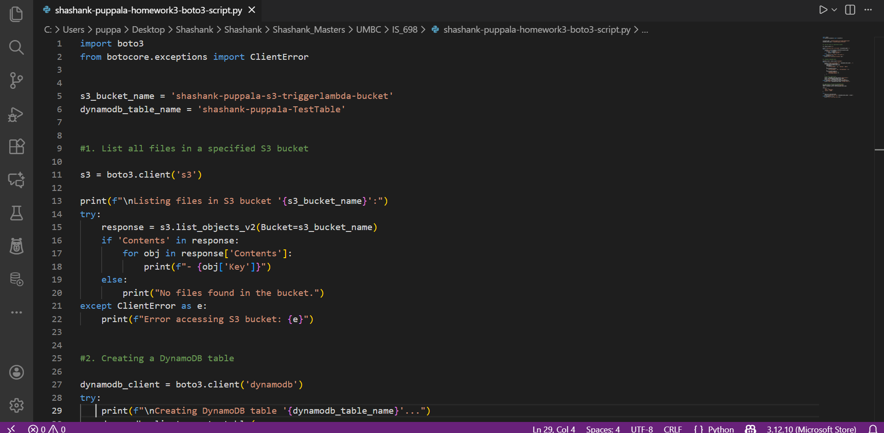

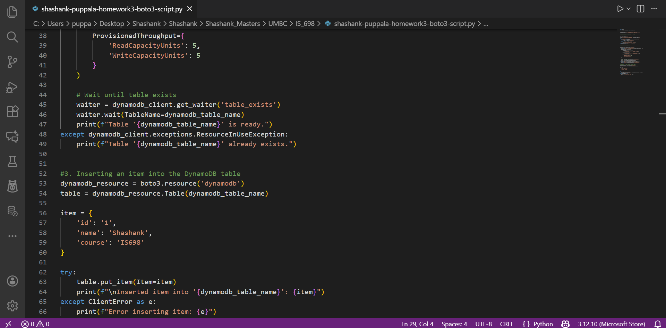

CLI output after executing the python boto3 script -

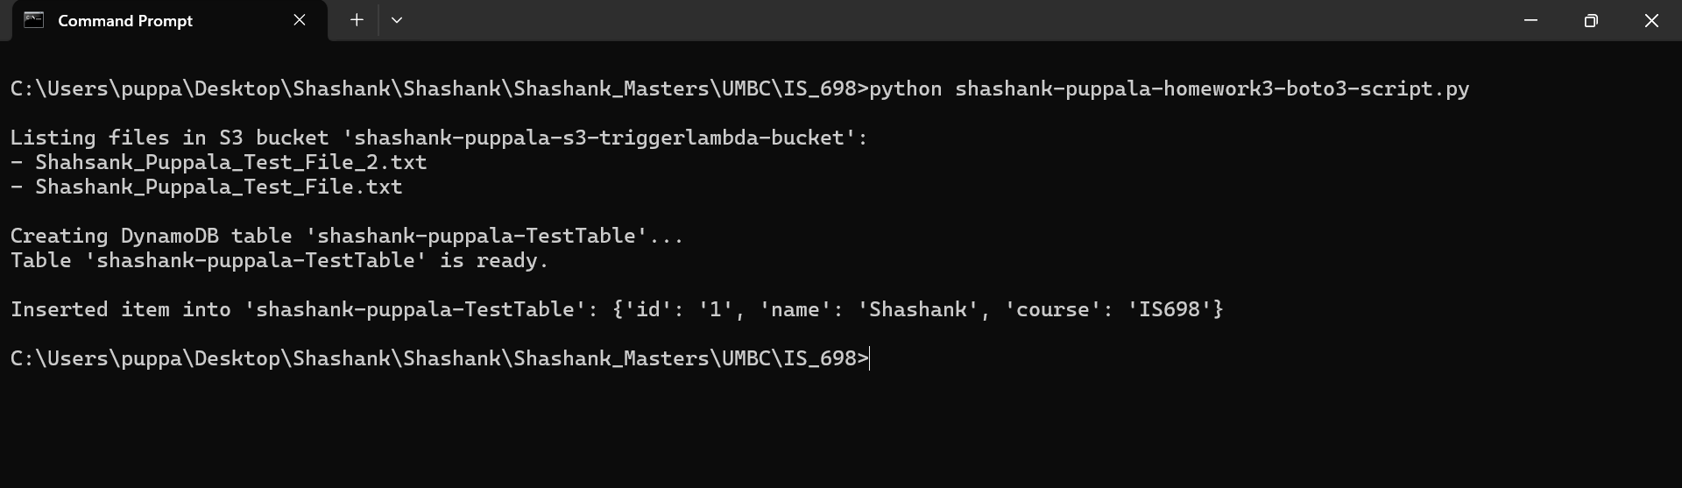

Validate in the Console whether the specified S3 bucket has the respective files or not, and check if the DynamoDB table is created and item is inserted into it;

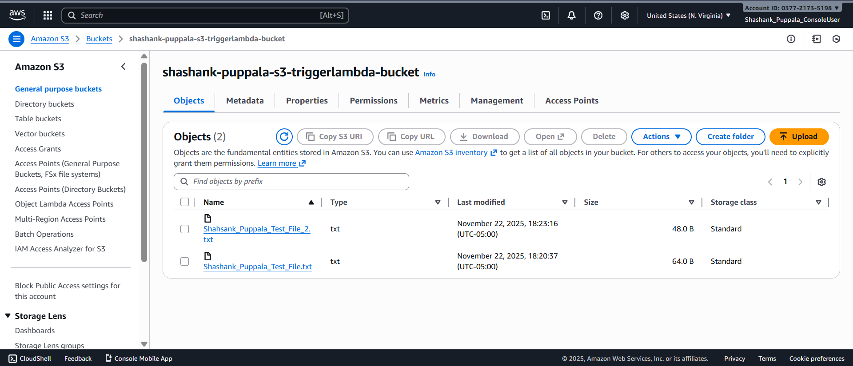

DynamoDB table and Item inserted in it -

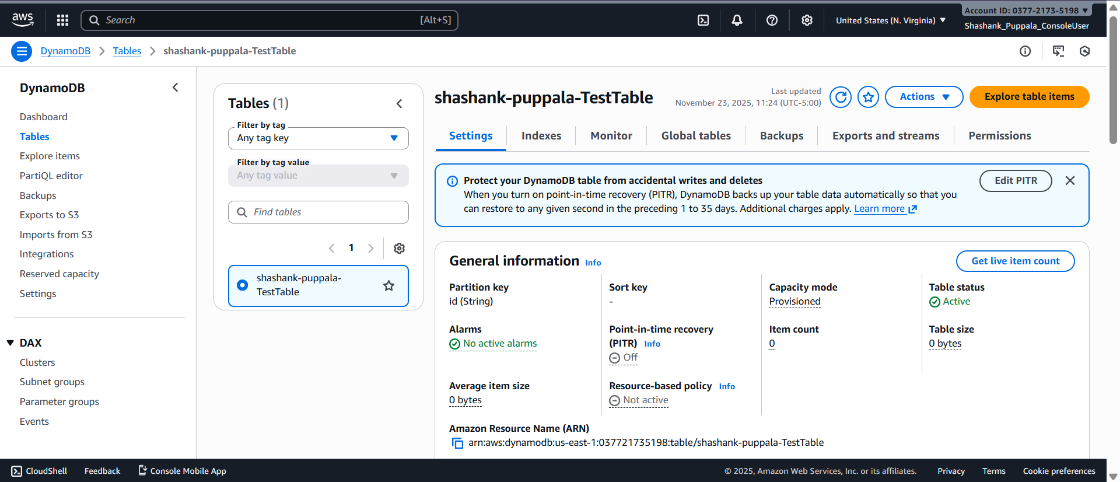

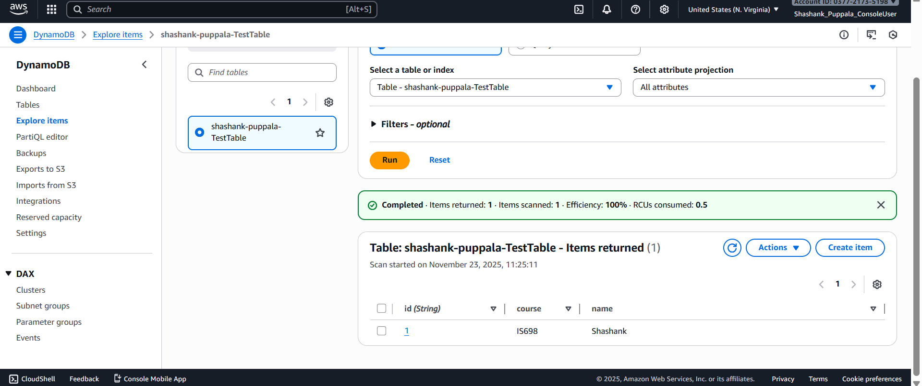

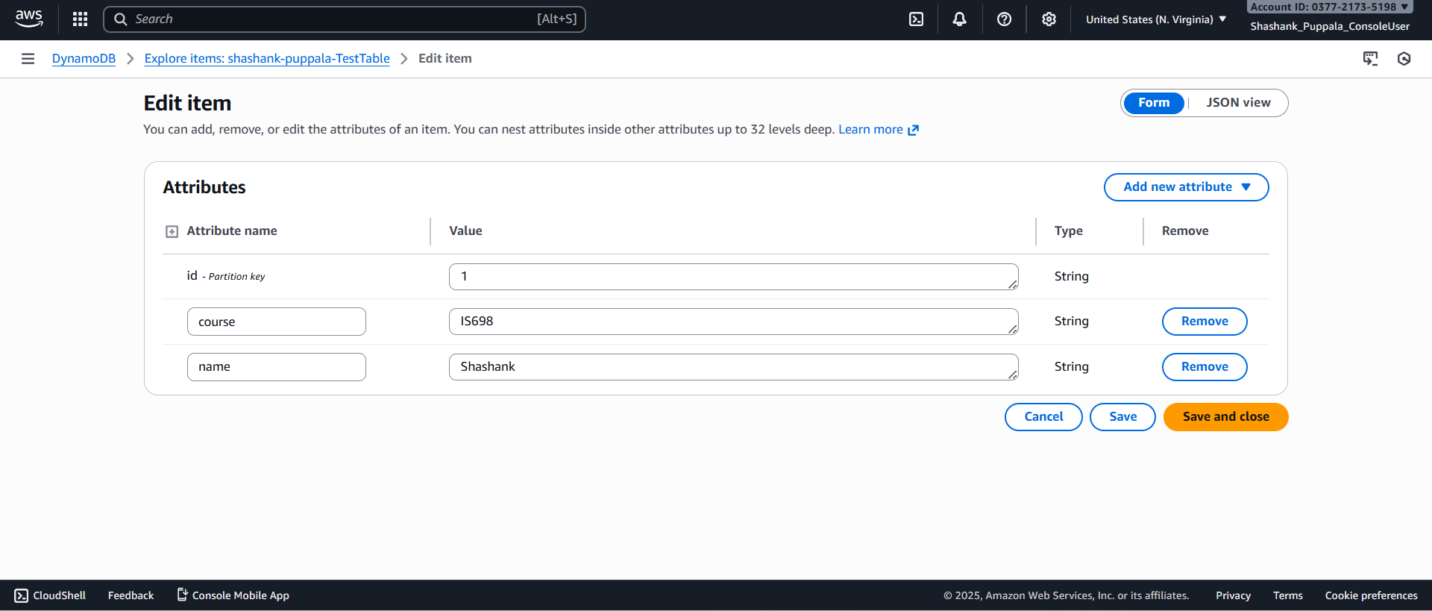

**Operations Performed -**

The Boto3 operations performed are as follows;

a. **Listing all the files in the specified S3 bucket** – Have written a Python code using Boto3 to get into the specific S3 bucket and retrieve all the objects present in it. This operation helps check what's inside the S3 bucket from CLI directly without the need to log into the console.

b. **Creating a DynamoDB table** – Wrote the Python script to create the DynamoDB table using the Boto3 DynamoDB resource. Defined the table name, Partition key (Primary key), and read/write capacity in the code. This code will specify the configurations required for AWS to build the DynamoDB table.

c. **Inserting Item into the DynamoDB table** – After creating the DynamoDB table, inserted the item data into it using put_item(). The record inserted into the DynamoDB table consists of data related to ID, Name, and other custom data such as course information. This way data insertion can be automated using the Python script.

**Additional Enhancements:** While in the above code, we have specified a particular bucket name from which the objects have to be retrieved. But instead of that way, we can make it dynamic as well, where user can input the bucket name and retrieve the files as follows;

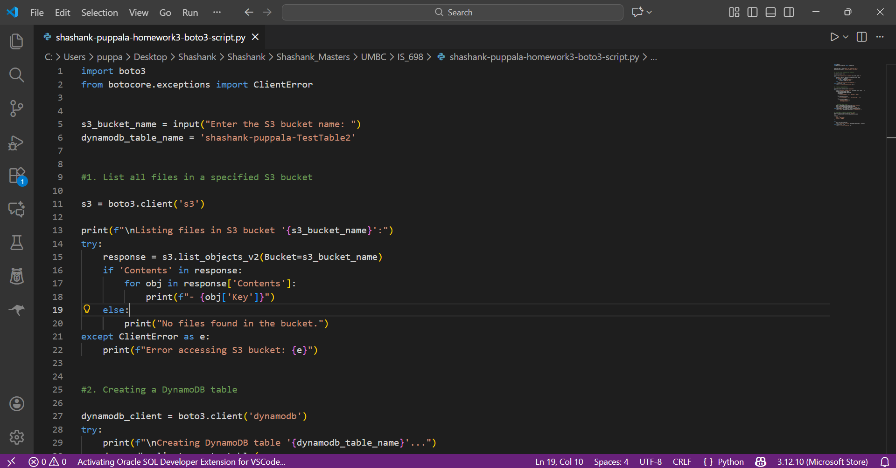

User can input their required S3 bucket name and retrieve the files;

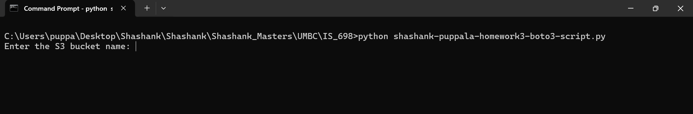

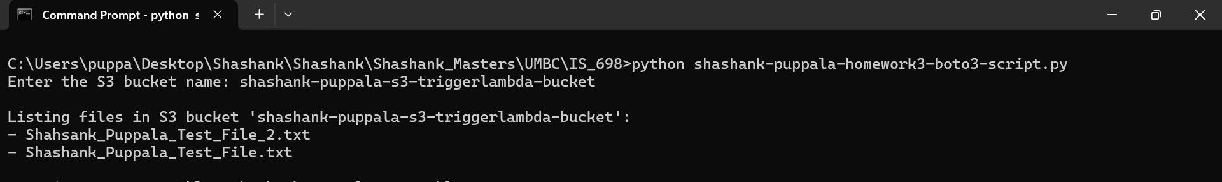

### **Part 5: Written Questions (5 points)**

**1.** What are the advantages of using CloudFormation over manually creating resources?

**1 Ans:** Few of the main advantages of using cloud formation over manually creating resources are as follows;

a. **Automation and Efficiency** – CloudFormation allows you to automate the process of resource creation, instead of creating resources manually one by one in traditional format.

b. **Scalability** – Can create any number of resources and complex architectures using the templates. It's really difficult creating hundreds of resources manually, whereas CloudFormation can simplify this process using the template.

c. **Repeatability and Consistency without human errors** – Once the template is created, the same can be repeatedly used to create various resources in different regions. And as it is the template creating the resources, there will be minimal errors, and human errors can be completely eliminated.

d. **Version Control** – Stores the templates, and these can be reviewed, and changed whenever new changes are required. So, it's easy to deploy new changes without issues which are trackable and reversible.

e. **Option to Rollback** – In case of deployment failing and resource is not created, it's easy to rollback in CloudFormation maintaining the infrastructure integrity.

So, these are the advantages of using CloudFormation over manually creating resources.

**2.** How does the event-driven model of Lambda improve application scalability?

**2 Ans:** Lambda follows the event-driven model. It will automatically respond to incoming events, without any server management or human intervention in the creation of resources. Now how does it improve the scalability is, lambda functions run only after being triggered, instead of running continuously and staying always on. This will make sure there are no unnecessary instances running in the background. So, if the incoming volume of events increases, it automatically launches instances concurrently to avoid the delay and scales horizontally to meet the on-demand needs. This concurrency management will not allow any sorts of bottlenecks, and makes sure the applications are adapted to varying loads without any pre-provisioning of resources. So, as lambda is fully managed by AWS, everything right from scaling of resources to concurrency control is done by AWS in background making sure application stays running in case of heavy loads and pays only for execution duration. So, this is how lambda’s event-driven model improves application scalability.

**3.** Why is it important to manage AWS resources using the CLI in addition to the Console?

**3 Ans:** It's important to manage AWS resources using CLI even though we have Console, as it gives more control and efficiency. Console really comes in handy and is required when you want to check something visually and understand what's actually happening with resources. But CLI is very useful when it comes to handling resources across multiple environments, workflow automation, and when it is required to perform multiple repetitive tasks at a higher scale. By using a single CLI command, a user can create, update, delete, and perform all the operations on the resources instead of going around and clicking on each resource.

One more reason to manage AWS resources using CLI is that it reduces human errors, speeds up the process, and saves a lot of time. This precision and accuracy of using CLI is very important and required in real world projects which are under time constraint and need a large number of resources. So, Console and CLI go together in managing the AWS resources, Console for clarity and visualization, and CLI for speed and precision at large scale.

**4.** What are the benefits of using Boto3 in Python scripts for AWS automation?

**4 Ans:** Firstly, Boto3 is an AWS SDK for Python which is used to write code to interact with AWS resources. Working using Boto3 in Python scripts for AWS automation basically makes it easier to handle the AWS resources and perform the operations. Instead of logging into the AWS console every time and selecting the resources required for the operation, the user can just write a few python lines and run the script to perform all the operations. By using Boto3 in Python scripts users can save a lot of time, reduce human errors as script performs the operations for you, and can perform the repetitive tasks easily any number of times.

Most importantly, the python scripts allow you to add the logic as you require, i.e. to customize the resources according to your requirement, use loops for repetitive and multiple tasks, and add conditions wherever you require. All these operations are not possible from the console and can be done easily just by using Boto3 in Python scripts. An additional benefit is that, as the scripting language is Python, it is easy to understand and read and can perfectly align with any project or automation which is ongoing.

So, in simple words, we can conclude that Boto3 allows users to automate AWS in a faster, consistent, and efficient way without much need of additional effort and is also easy to use.